PGADMIN's PASSWORD = jasmine

Module 2 - Relational Databases

**Exercice : a patient appointment system**

*Draw the following system using the crow foot notation*

A doctor "One and only One"can be scheduled for many appointments, "Many to Zero"but may not have any scheduled at all. Each appointment is scheduled with exactly 1 doctor.

A patient "One and only One" can schedule 1 or more appointments. One appointment "One to Many" is scheduled with exactly 1 patient. An appointment must generate "One and only One" exactly 1 bill, a bill "One and only One" is generated by only 1 appointment.

One payment "One and only One" is applied to exactly 1 bill, and 1 bill "Zero to Many" can be paid off over time by several payments. A bill can be outstanding, having nothing yet paid on it at all. One patient "One and only One" can make many "Many to Many" payments, but a single payment is made by only 1 patient.

Some patients are insured by an insurance company. If they are insured, they can only carry insurance with one company. An insurance company can have many patients carry their policies. For patients that carry insurance, the insurance company will make payments, each single payment is made by exactly 1 insurance company.

List of entities:

* Doctor
* Appointments
* Patient
* Bill
* Payment
* Insurance Company

Between Many to Many Relationship

We will need to make an intermediate link to between the two concepts. We will make a particular case of two primary keys. This presents the most difficult relationship, because it imposes to create another table.

As soon as you see the Many to Many relationships. Then you know that you should create another intermediate table, it's mandatory. There is no other way to pass it.

Between One to One Only Relationships

When you see one and only one relationships on both sides of the entity, you will have two choices. Either to put student into seat, or seat into the student, by the primary keys.

* *Student_name "primary key"
* *Seat_number "primary key"

What is the impact of creating an intermediate table?

It's also called the association table, it associates two-many to many entities. It will link other entities.

Toward implementation : a patient appointment system

*Create the Tables corresponding to the diagram you just designed*

You will probably have to add attributes to entities, like in the following exemples

*Remember : CREATE TABLE syntax - instruction*

CREATE TABLE DOCTORS (

doc_id integer NOT NULL,

doc_firstname varchar(255) NOT NULL,

doc_lastname varchar(500) NOT NULL

);

**Query Tool**

To open the query tool, right click on the table and click on the query tool.

It's where we write SQL querries in order to manipulate and operate the database

Creating a Table "Entity" and Attributes

CREATE TABLE DOCTORS(

doc_id integer NOT NULL,

doc_firstname varchar(255) NOT NULL,

doc_lastname varchar(500) NOT NULL

);

Executing the Query

Paste the code into the query tool, click play to execute the entity creation code, and after - right click on your table section under the database and refresh the tables.

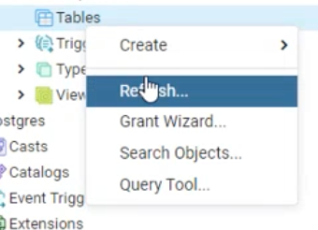

We will now be able to see the doctor's entity, after refreshing the tables.

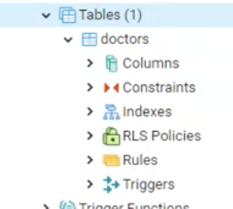

Creating a Table "Entity" and Attributes

CREATE TABLE DOCTORS(

doc_id integer NOT NULL,

doc_firstname varchar(255) NOT NULL,

doc_lastname varchar(500) NOT NULL

);

Explanation

It creates an entity with 3 columns of type one integer value and two of type varchar.

WHAT'S A VARCHAR?

Varchars are Strings.

* in here, which is limited to length of 255 and 500 in terms of length.

We have a doctor entity.

* This entity has an integer value, which should not be a NULL, or empty.
* We have the firstname of the doctor as a limited length number of 255 varchar, which should not be a NULL.
* We also have the Doctor's lastname with a limited length of 500 varchar, which should not be a NULL.

WHAT'S a NULL VALUE?

NULL is not like an empty string. NULL means not set, because empty is a little bit ambiguous.

If it's NULL, it means that NOT SET at all.

To Modify the Structure of a Table

Add a column by the name of "bdate" of type DATE; to doctor's table.

*ADD COLUMN*

ALTER TABLE DOCTOR ADD COLUMN "bdate" DATE;

ALTER TABLE DOCTORS ADD COLUMN "bdate" DATE;

To Drop "Remove" A Column in a Table

We use the alter command followed by table and name of the table, followed by drop column name.

NOTE: You can lose all your data present in that column when you drop a column of the table.

DROP (REMOVE) COLUMN

ALTER TABLE DOCTORS DROP COLUMN "bdate";

ALTER TABLE DOCTORS DROP COLUMN "bdate";

VERY IMPORTANT

Run the execution of the command by selection, which means to select the new code or line you just wrote, or leave your mouse point in the row. it will only execute that line. And, then refresh your table.

You can see that I have a selection of the line, i wrote. I execute the selection. OTHERWISE, it will re-run everything. Re-Running everything will re-create the table doctor, even if it exists. SO RUN THE NEWEST LINE YOU WRITE BY SELECTING IT.

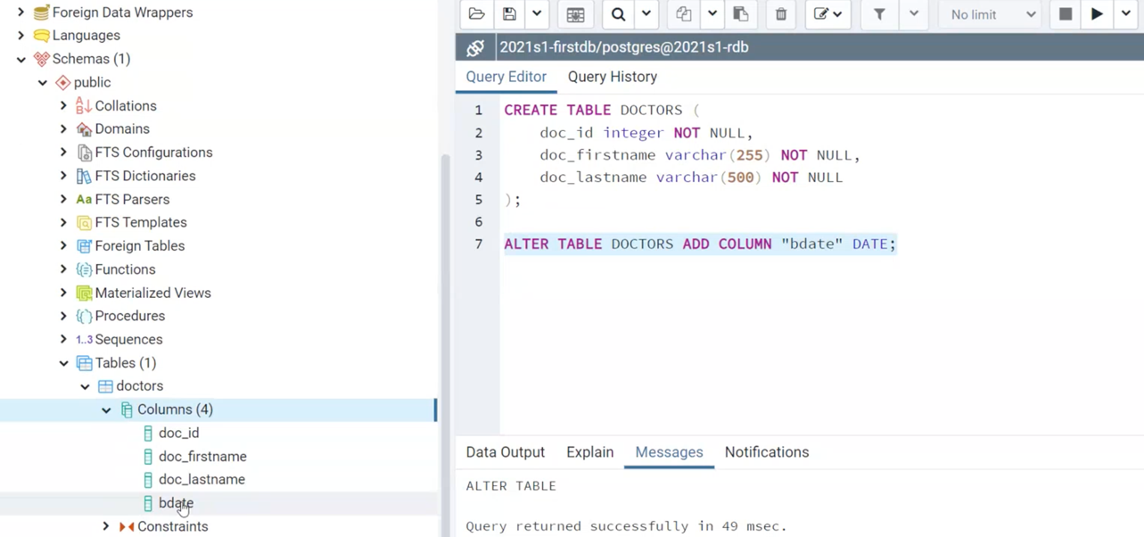

We can see the bdate column. It's created.

We can remove the added column by the command we have in drop or remove section.

To Duplicate a Column

By duplicating means, it will take the data from an existing original column and put it into a new column, which we named it as "newCol"

*ADD COLUMN*

ALTER TABLE DOCTORS ADD COLUMN "newCol" DATE;

UPDATE DOCTORS SET newCol = bdate;

ALTER TABLE DOCTORS ADD COLUMN "newCol" DATE;

UPDATE DOCTORS SET "newCol" = "bdate";

We can see the duplicated new column called "newCol" and we have only executed the new added code or line.

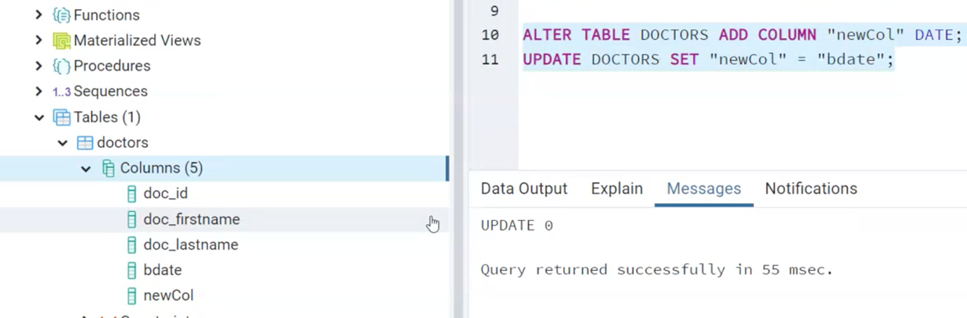

Creating Constraints: Primary & Foreign Keys

* Once, you created your table, you can create your constraints. \

To create consistency, we must avoid duplication. If we create duplicates, we will face plenty of problems. That's why we use the PRIMARY KEYS to enforce the unicity and uniqueness of our ROWS in the TABLE. We put the primary key inside the parathesis.

* We can have multiple primary keys.
* We must separate them by commas. PRIMARY KEY (doc_id, student_id);

Once, we identify our primary key. Once, we make it unique with a primary key in our table row, we can reference and target it from external tables.

Once, the primary key of a table is used in another or external table, It's called the foreign key, which is only a reference to that table.

## Creating constraints : syntax

PRIMARY KEY

ALTER TABLE ONLY DOCTORS ADD CONSTRAINT doc_pk PRIMARY KEY (doc_id);

FOREIGN KEY

ALTER TABLE ONLY APPOINTMENTS ADD CONSTRAINT fk_doc FOREIGN KEY (f_doc_id) REFERENCES DOCTORS(doc_id) ON DELETE SET NULL;

Notice the ON DELETE SET NULL meaning that if a doctor is deleted, then the appointment remains with null in the f_doc_id field

Explanation

It alters or modifies the table doctors.

* It adds a constraint of the type of PRIMARY KEY
* The constraint is named doc_pk
* It makes doc_id as the primary key of this table.

ALTER TABLE ONLY DOCTORS ADD CONSTRAINT doc_pk PRIMARY KEY (doc_id);

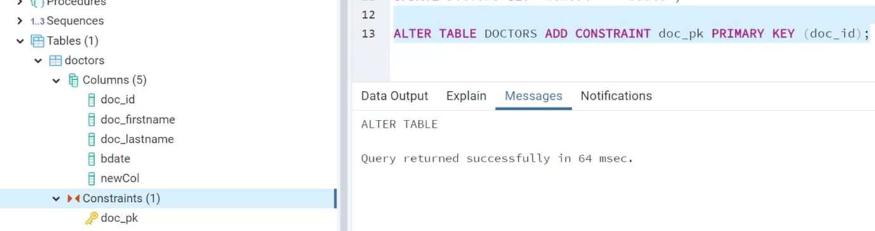

**Constraints**

SQL constraints are used to specify rules for the data in a table. We defined a rule for a primary key using constraints.

Now, under the constraints, we can see the constraint that we just created. The constraint is called Doc_pk.

This constraint which is called "doc_pk" is specifying the rule for our primary key which is "doc_id" in doctors table.

EXERCISE

Create the appointments table and define the primary key, and then we will define the doctor id as a foreign key in the appointment table.

Creating Appointments Table:

CREATE TABLE APPOINTMENTS(

app_date DATE NOT NULL,

app_time TIME NOT NULL,

app_duration INT NOT NULL,

app_reason varchar(255) NOT NULL

);

ALTER TABLE APPOINTMENTS ADD CONSTRAINT app_pk PRIMARY KEY (app_date, app_time);

ALTER TABLE APPOINTMENT ADD COLUMN "app_date" DATE;

ALTER TABLE APPOINTMENTS ADD COLUMN "app_time" TIME;

ALTER TABLE APPOINTMENTS ADD COLUMN "app_duration" INT;

ALTER TABLE APPOINTMENTS ADD COLUMN "app_reason" CHAR;

ALTER TABLE APPOINTMENTS ADD COLUMN "f_doc_id" INT;

ALTER TABLE APPOINTMENTS ADD CONSTRAINT fk_doc FOREIGN KEY (f_doc_id) REFERENCES DOCTORS (doc_id);

TWO PRIMARY KEYS CONCEPT

We need two primary keys, because we will have this time every week. That's why we have a pair of primary keys for the APPOINTMENTS only.

The concept is that we will only have one primary key, which is composed of several keys.

Adding Primary & Foreign Keys Graphically.

We can add primary and foreign keys graphically as well. We can go to Constraints > a primary key such as doc_id > right click > properties > under the definition menu.

It's not advised.

How to add a FOREIGN Key from Appointments to Doctors Entity?

The structure of the foreign key is exactly the same as primary key.

* You must first create a column for the foreign key first. and then create a foreign key of the primary key, referencing.
* You add a constraint in the name of fk_doc for the constraint.
* We have the definition of constraint rule for a foreign key. FOREIGN KEY "f_doc_id"
* Which references the column doctor id. REFERENCES DOCTORS "doc_id"

Remember:

You must create a column for the foreign key first before using the PRIMARY key of doctors. If there isn't any column available, how can you add the foreign key.

The foreign key is applicable only if you have a primary key. Otherwise, you will not have a unique target.

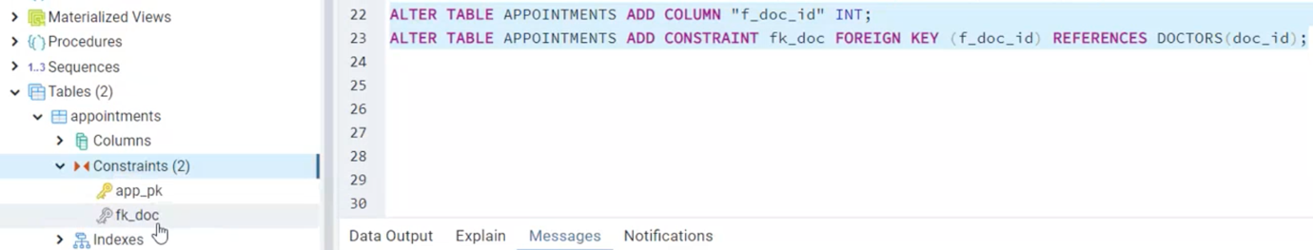

We can see the foreign key as silver. We first created the column first and then the foreign key.

EXERCISE

As an intermediate step

1. Create the tables and it's types, using the same kind of diagram.
2. Identify the primary and foreign keys.
3. Be careful of what will hold the value of primary key and a foreign key with naming.
4. Once, your physical diagram is completed, then just translate your diagram into SQL queries.
5. IN THIS EXERCISE WE DON'T HAVE TO CREATE AN INTERMEDIATE TABLE, BECAUSE THERE AREN'T MANY TO MANY RELATION.

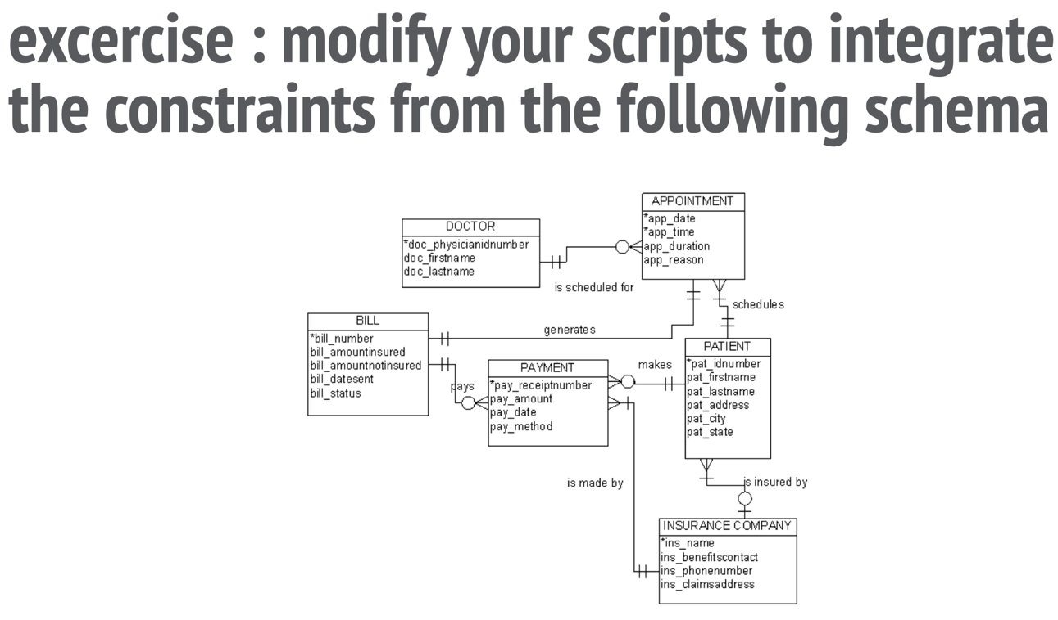

Professor's recommendation is to build your physical model first. Make an effort of identifying the primary and foreign keys.

Once, you finished this model, try doing the something with the other model.

This model has a MANY TO MANY relation, create the intermediate table.

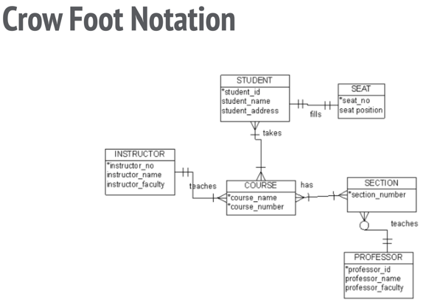

The intermediate table consisting of two foreign keys.

1. One foreign key for the students.
2. One foreign key for the courses.

**Mod-3**

Many to Many Relation - Medium Table

In many to many relation, we can have several foreign keys in the medium table to reference the external table. Even, if we have two, three or more Many to Many relations, we can created medium or intermediate table.

Or maybe not if we can connect them in one. It depends.

If you don't have the specification of many to many link or relation. What is the specification?

We have two types of Many to Many relations.

1. Purely technical: For example, a car can be owned by many owners and an owner can have many cars.  
     
   In this case of implementation of Many to Many relationship, we create an intermediate or medium table with Many to One. But there is no added value by the intermediate table.   
     
   There is no extra column. To represent it, we need two dimensions.
2. Relationship between the students and courses. What can be the relationship?   
   It can be different things. It can be the grades. It can be the lecture. You can add them in the middle or medium table.

In these cases, we don't only have the foreign keys. We will have the foreign keys and the extra information.

To represent it. We need three "students, grades, courses" dimensions and at the intersection you have the grades.

It is also called a DATA CUBE because it has 3 dimensions. It's mostly used in business intelligence because you want to link two data by another attribute.

Many to Many relationships - a couple of many to many in one diagram.

You need to translate the many to many relations into an intermediate table for example, lectures and grades.

If it's the same information in the same table or related that can be used.

Generally speaking, it's better if you can reduce relations from to many to one.

Note: One to one is not used so much. It might indicate that you have a design problem. Why? Because it might have some heaviness that's not needed. One to One means, it's a complimentary concept. Maybe not to get the data exposed.

DDL "Data Definition Language"

It's directly performable in the form of DDL. Which means the database structure.

* The one - to one
* The zero or many - to one
* The one or many - to one

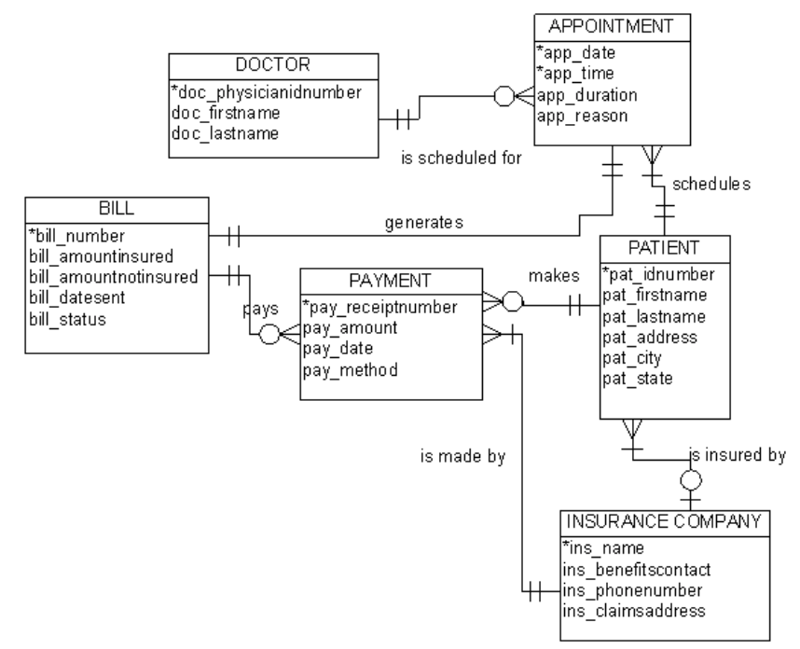

If we want to implement the BILL table.

First, we will create a table and its attributes and then the primary key. If needed a foreign key.

CREATE TABLE BILL (

BILL_NUMBER INT NOT NULL PRIMARY KEY,

BILL_AMOUNTINSURED MONEY NOT NULL,

BILL_AMOUNTNOTINSURED MONEY NOT NULL,

BILL_DATESENT DATE,

BILL_STATUS VARCHAR(500)

);

Can we identify the BILL outside the DATETIME information? It's linked to the APPOINTMENT which has a DATE & TIME already.

WHERE to store the LINK between the APPOINTMENTS TABLE AND BILLS TABLE?

It depends.

Depends on what?

It depends on how you use it. If you are browsing the appointments and then searching the associated bill. It will be better to store in the appointment.

But

If you are always using the bill, then it will be better to store in the BILL. Right now, you have the choice.

Depends on how you prefer.

NOW IF WE WANT TO STORE IN THE BILL TABLE. THE LINK...

It will be like this:

CREATE TABLE BILL (

BILL_NUMBER INT NOT NULL PRIMARY KEY

BILL_AMOUNTINSURED MONEY NOT NULL,

BILL_AMOUNTNOTINSURED MONEY NOT NULL,

BILL_DATESENT DATE,

BILL_STATUS VARCHAR(500)

APP_DATE #appointment table link

APP_TIME #appointment table link

);

What's the problem with the time zone? Why is it important to take into account when you record date and time?

For International Data Usage. 03:00 AM of 13 APRIL, in some countries it will be 14 April.

This is when you want to have an Absolut or exact time. Without a time, zone.

These are the worst topics we will have in computer science:

Time zone

Encoding

Links

TO DROP A COLUMN:

ALTER TABLE BILL DROP COLUMN APP_TIME;

#we had a mistake, defined it as date.

TO RECREATE A NEW COLUMN AFTER THE DELETION:

ALTER TABLE BILL ADD COLUMN APP_TIME TIME;

FOREIGN KEY

ALTER TABLE BILL ADD CONSTRAINT appointment_fk FOREIGN KEY(APP_DATE, APP_TIME) REFERENCES APPOINTMENTS (APP_DATE, APP_TIME);

ALTER TABLE BILL ADD CONSTRAINT appointment_fk FOREIGN KEY (APP_DATE, APP_TIME) REFERENCES appointment (APP_DATE, APP_TIME);

So far, we have learned.

* Creating tables
* Adding columns
* Dropping columns
* Adding a primary key
* Adding a foreign key
* Linking columns
* Not mixing the Data TYPES "Int, Money, VarChar(500), Date, Time,"

Why should we have links between the data?

Because we need them. Otherwise, how can we find out the exact doctor and which exact patient. At some point, I need the list of appointments for the day. The association of patients with date and time with the doctors.

Those linking are helping us.

Fetching DATA

After we make the link. Then we can fetch the same way from the patients.

What if you want to have the list patients from the doctor?

Having or selecting the doctors table and filter the list of patients for a given date.

What is your first reflex? How can we browse the appointment from the Doctor? We can't browse the appointment from the doctor. BECAUSE the link is made in the APPOINTMENT table.

So, Actually, we should browse for the information about the doctors and patients from the APPOINTMENT table.

We can fetch the data from the table that is storing the link between the two tables.

Structuring the Database:

Create Table & Alter Table was used in structuring the data.

JOIN - Relational Databases

It will allow us to aggregate "combine" and to project the data from different tables using the links that exists between the tables.

We have two kind of JOINS:

1. Using JOIN with the primary and foreign key definitions.
2. Handmade JOINS, where we can create different tables and you try to aggregate "combine" the result using "conditions" "where" clauses.

The QUERY Language

Now, we are entering the query language. Previous steps were all about the definitions. We are entering to the query section. Where we can do queries on our databases.

After modelling we enter to data manipulation. We can summarize the 80-90% of the usage with these four operations called as an ISUD.

ISUD "Insert, Select, Update, Delete" Queries.

Insert: a query to insert data into the table.

Select: a query to fetch the data

Update: a query to update the data

Delete : a query to delete the data.

INSERT "CREATE A ROW"

How can we insert data into an existing table?

IT will create a new row in the FACILITIES table some specified rows and will insert values.

Insert into "name_of_table"all the columns that are supposed to exist already, and then the values

INSERT into facilities(facid, name, membercost, guestcost, initialoutlay, monthlymaintenance) values (9, 'Swimming Pool', 8, 16, 3000,3000)

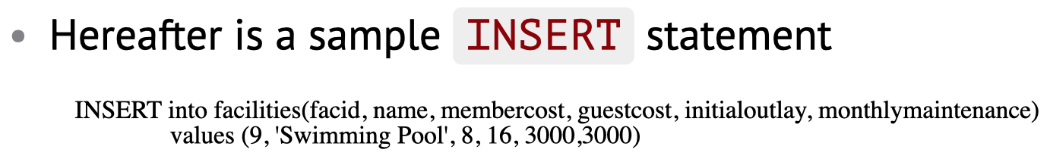

Recommendation: Use the parenthesis for a clear view.

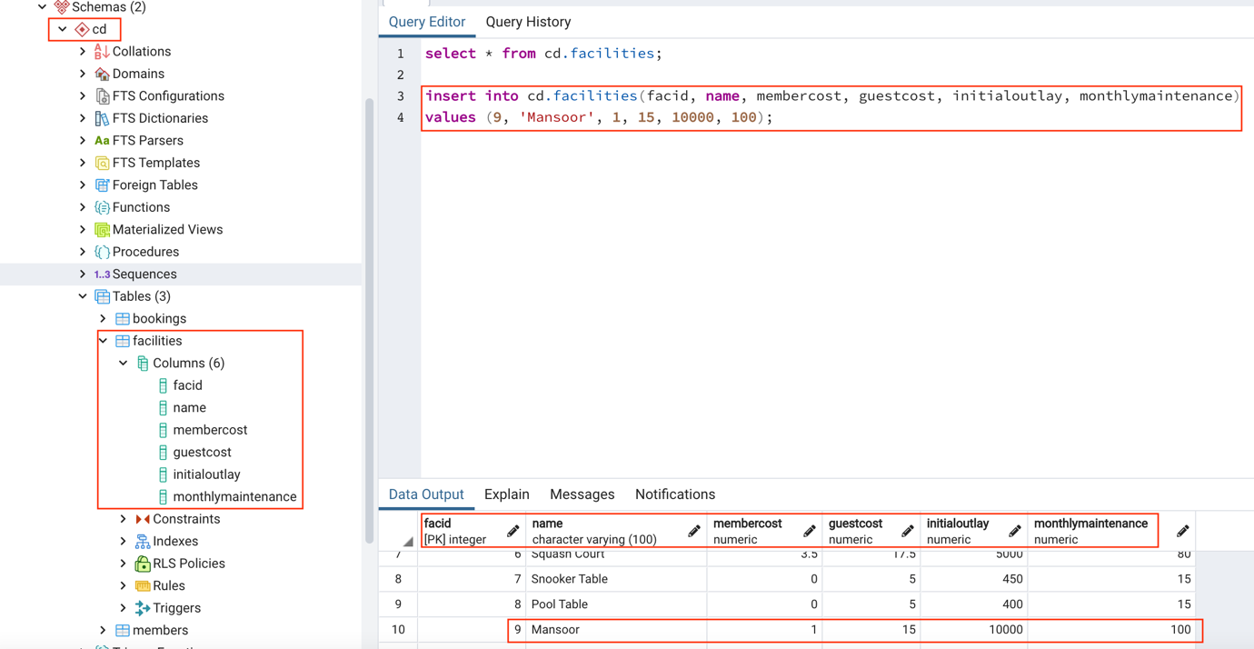

Command:

insert into cd.facilities(facid, name, membercost, guestcost, initialoutlay, monthlymaintenance) values (9, 'Mansoor', 1, 15, 10000, 100);

ROWS

* facid "primary-key"
* name
* membercost
* guestcost
* initialoutlay
* monthlymaintenance

VALUES FOR EACH OF THE ROW"

* facid = 9 "because, below 9 is given as primary keys."
* name = Mansoor
* membercost = 1
* guestcost = 15
* initialoutlay = 10000
* monthlymaintenance = 100

UPDATE "UPDATING A LINE or A ROW"

Once we inserted it. For modification we can update.

Update the table facilities column SET the membercost row to 10 WHERE the ROW name is Mansoor "the name mansoor will not be touched."

UPDATE facilities SET membercost=10 WHERE name='Swimming Pool';

UPDATE facilities SET membercost=10 WHERE name='Swimming Pool';



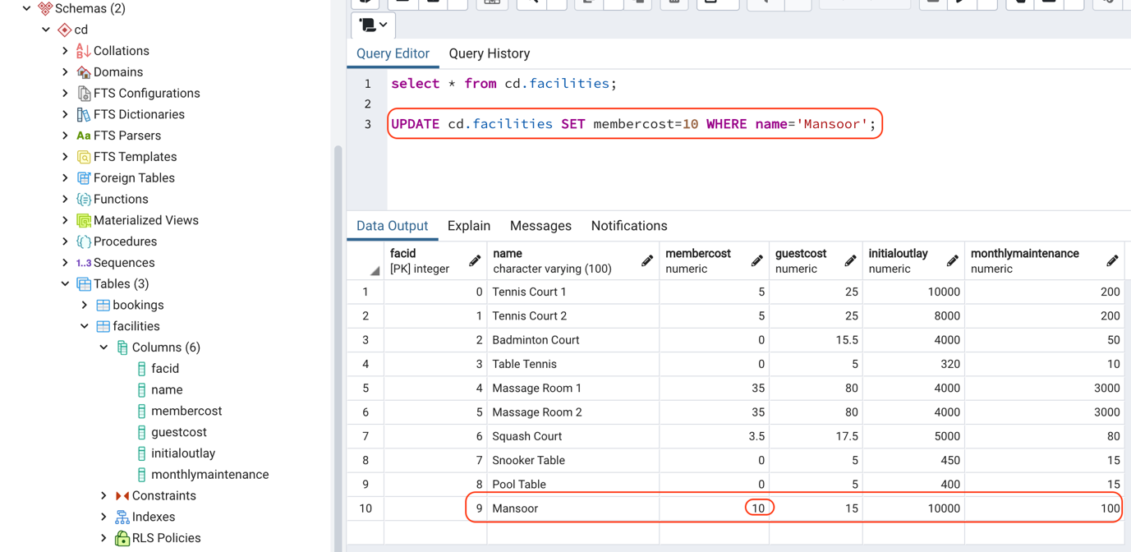

Command:

select * from cd.facilities;

UPDATE cd.facilities SET membercost=10 WHERE name='Mansoor';

NOTE:

During the update of a column, we must pay attention because "WHERE name='Mansoor' ", there can be so many rows by the name of Mansoor and it can be hurtful.

SET = This operator targets a column and replaces the old value.

Note:

Never do modifications using name because, we don't know if there is only one swimming pool in our database. There could be an interaction. Always use the ID or primary key.

Never code this way in an application.

In Applications it's always like this:

It's

* We search,
* We select a row,
* We display the detail,
* We either modify or delete.

NOTE: When you select, you have the idea of the row you selected. You can do WHERE for select only. NOT for UPDATE.

Before using the DELETE query, always make sure to take a backup by doing a select before the update.

DELETE A ROW

Delete the entire row. Don't do it. Always do a select where you will have a dump to reinterpret them and take a backup. It's a quick and definitive way of getting fired from a company.

DELETE from facilities WHERE name='Swimming Pool';

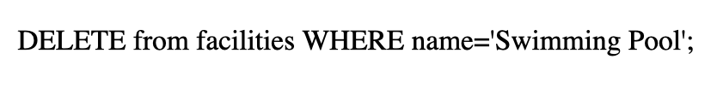

SELECT - FROM

Select a set of columns that you want to select a certain columns from a set of tables. It's like a virtual table. It will not affect if you make some modification.

* Select a specific column of an existing table specified by FROM.
* Logical & arithmetical operators can be used ("=", "<", ">", "<>", "AND", "OR")
* We can combine several conditions and some basic filters with less or greater than etc.

RUN QUERY

Select * from bookings;

Select * from facilities;

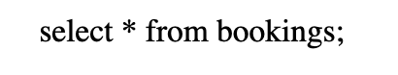

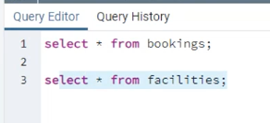

***Tip*** : if you have "relation not found", you have to update the search path

show search_path ;

set search_path = "$user", public, "cd";

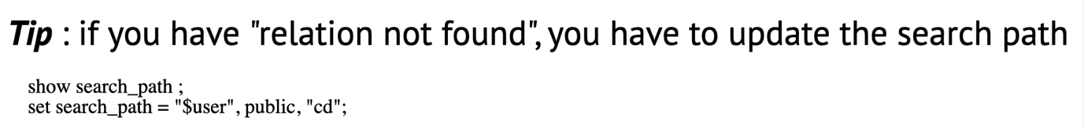

<https://pgexercises.com/>

Download the club-data provided in the slides. Open it with an editor or notepad. Copy the contents and open PGADMIN. Paste it. Run it.

Remember to remove on the of the content the location ex: c/windows - otherwise, it will give you an error.

The CLUBDATA has the CD Schema.

You will find the CD Schema under the Schema section of PGADMIN.

## WHERE CLAUSES "Filtering"

We filter using WHERE select * FROM column name WHERE monthlymaintenance less than 1000.

* SELECT * FROM facilities WHERE monthlymaintenance < 1000;
* You can write in Query Tool > under your database1.

We will be able to use these commands once we upload and have huge data.

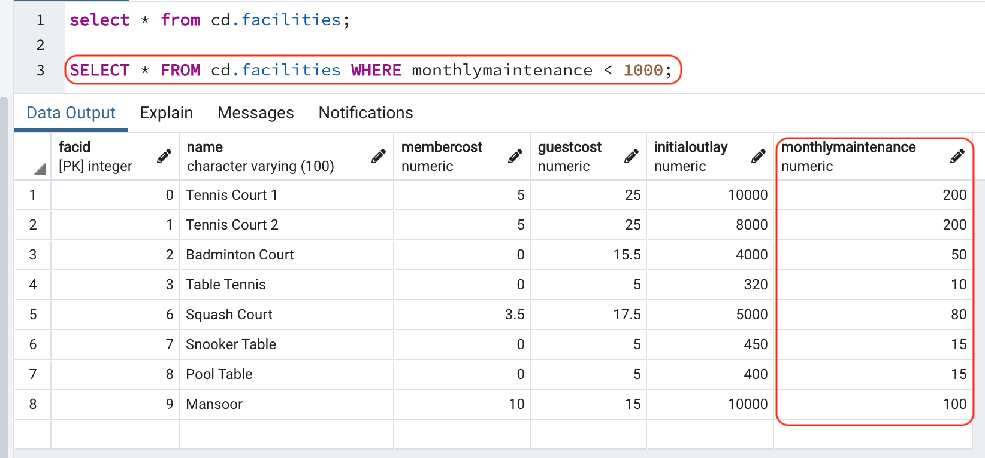

**Filtering by ROW Name 'Mansoor'**

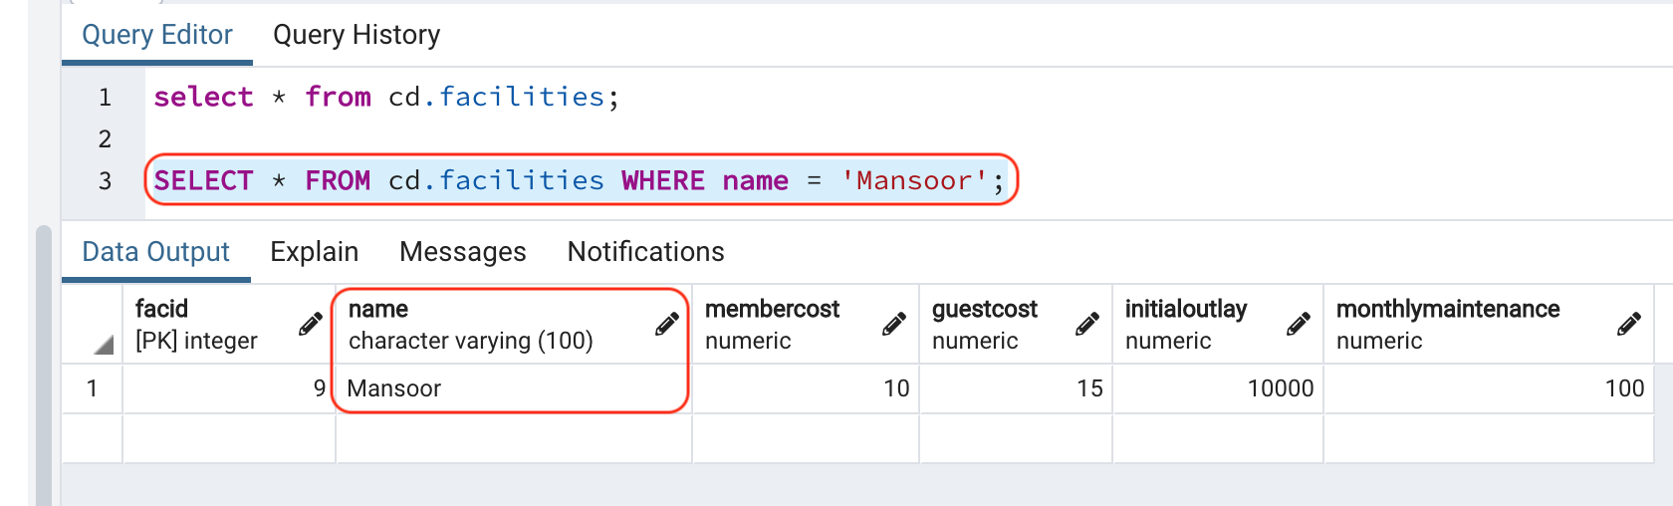

Command:

select * from cd.facilities;

SELECT * FROM cd.facilities WHERE name = 'Mansoor';

VIEW ROWS without SELECT QUERY

To view the rows. Right Click on the table and go to View/Edit Data > First 100 Rows.

Without writing select * from tatatat.

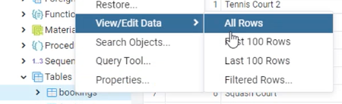

OR

Or to select a column from inside a schema.

CD = Schema

Bookings = Column

ORDER BY = arrange or filter by the ID

LIMIT 100 = 100 rows.

Select * FROM cd.bookings ORDER BY bookid ASC LIMIT 100

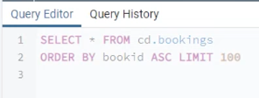

How can we recognize a human query? It's not a programmatic query, why? * is human query.

SELECT * FROM facilities WHERE monthlymaintenance < 1000;

We can recognize it because of a asterik. *

A computer cannot guess what is behind a star.

We can separate a column by a comma, while filtering. We can filter multiple columns.

* If we want to select the facid and name.
* SELECT * FROM facid, name = we will only get the projection from the original data.

Again, Do not use * "asterik" when you make a program or YOU ARE FIRED.

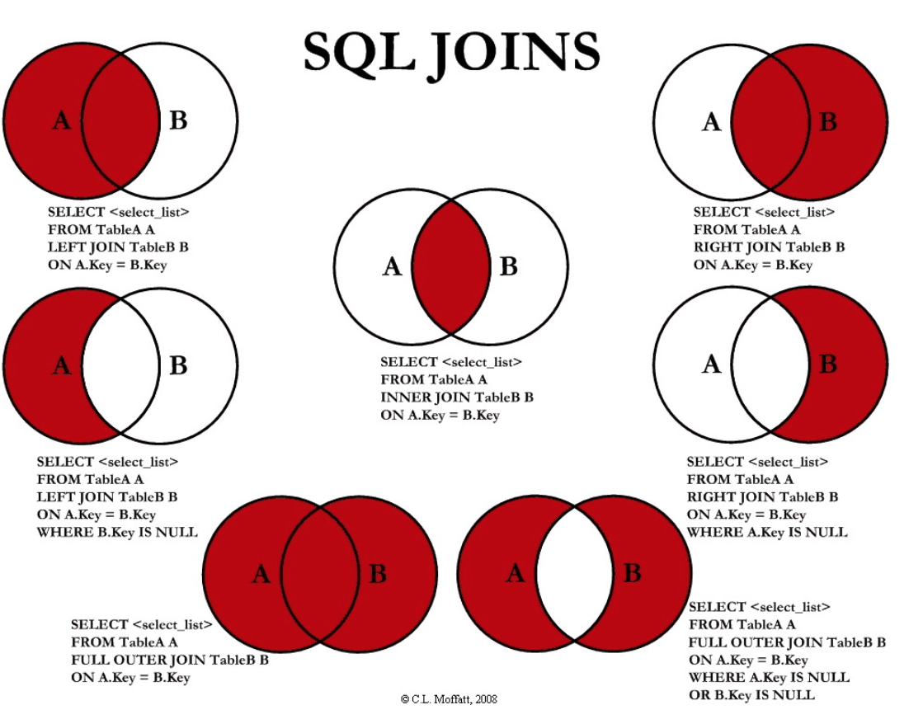

Introduction to PostgreSQL INSERT Into statement

The PostgreSQL INSERT statement allows you to insert a new row into a table.

The following illustrates the most basic syntax of the INSERT statement:

INSERT INTO table_a(a1, fruit_a1, …)

VALUES (value1, value2, …);

CREATE TABLE basket_a (

a1 INT PRIMARY KEY,

fruit_a1 VARCHAR (100) NOT NULL

);

CREATE TABLE basket_b (

b1 INT PRIMARY KEY,

fruit_b1 VARCHAR (100) NOT NULL

SELECT * from basket_a;

INSERT INTO basket_a (a1, fruit_a1)

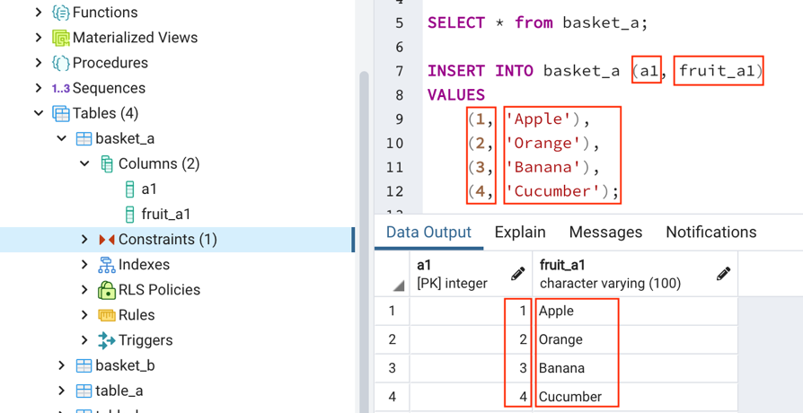VALUES

(1, 'Apple'),

(2, 'Orange'),

(3, 'Banana'),

(4, 'Cucumber');

Note:  
It will insert the numbers into a1 column and apple, orange, banana into fruit_a1 column.

INSERTING NUMBERS 1-4 and SOME FRUITS TO BASKET_B Table:

INSERT INTO basket_b (b1, fruit_b1)

VALUES

(1, 'Orange'),

(2, 'Apple'),

(3, 'Watermelon'),

(4, 'Pear');

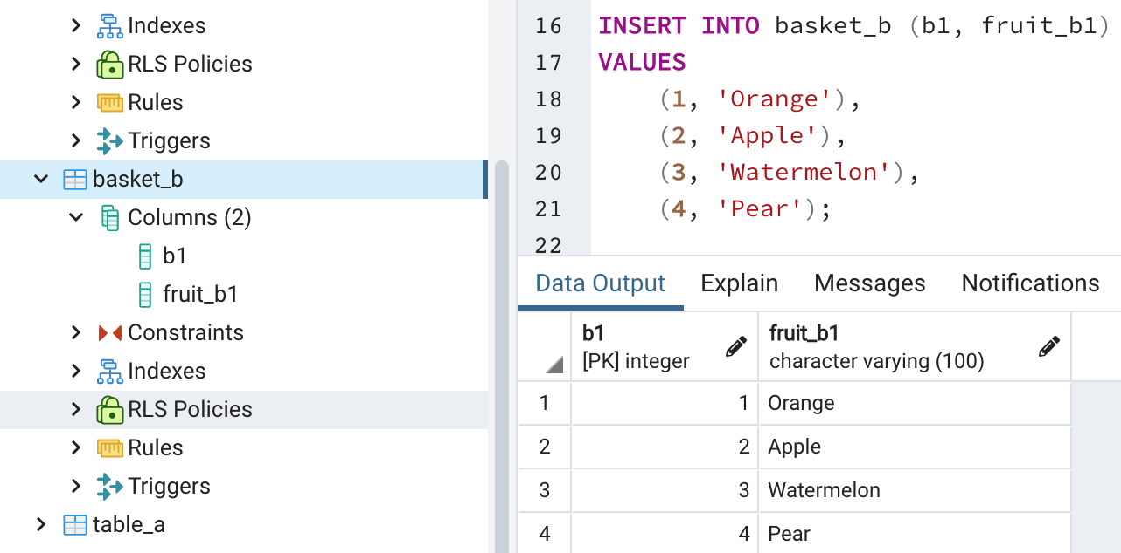

## PostgreSQL inner join

## To Only SHOW the Common ROWS

The following statement joins the first table (basket_a) with the second table (basket_b) by matching the values in the fruit_a and fruit_b columns:

SELECT

a1, #column name "a1"

fruit_a1, #column name "fruit_a1"

b1, #column name "b1"

fruit_b1 #column name "fruit_b1"

FROM

basket_a #table name

INNER JOIN basket_b #table name

ON fruit_a1 = fruit_b1; #Inner Joining the columns with string values "orange, apple, watermelon"

Code language: SQL (Structured Query Language) (sql)

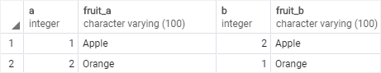

The inner join examines each row in the first table (basket_a). It compares the value in the fruit_a column with the value in the fruit_b column of each row in the second table (basket_b). If these values are equal, the inner join creates a new row that contains columns from both tables and adds this new row the result set.

The following Venn diagram illustrates the inner join:

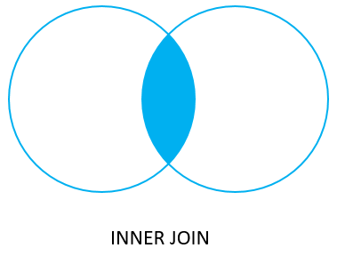

The inner join will only display the common rows of both compared tables.

SELECT a1, fruit_a1, b1, fruit_b1 FROM basket_a INNER JOIN basket_b on fruit_a1 = fruit_b1;

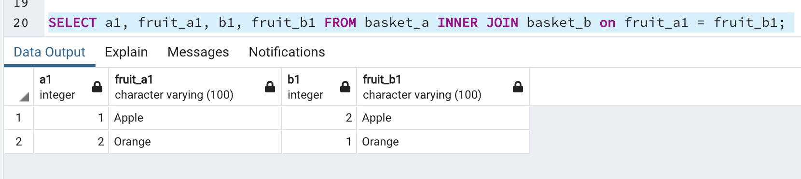

COMMAND:

SELECT a1, fruit_a1, b1, fruit_b1 FROM basket_a LEFT JOIN basket_b ON fruit_a1 = fruit_b1;

Professor Way:

SELECT * FROM table_a as a LEFT JOIN table_b as b ON a.pk = b.pk;

OR

SELECT a.pk, a.val, b.pk, v.val FROM table_a as a LEFT JOIN table_b as b ON a.pk = b.pk;

Left Join Exclusive:

**JOIN OPERATOR**

You can combine or merge data coming from different tables by using the JOIN operator.

We are trying to merge or combine the rows of the first table with the rows of the second table.

Command:

SELECT * FROM facilities JOIN bookings on bookings.facid = facilities.facid

WHERE monthlymaintenance < 15;

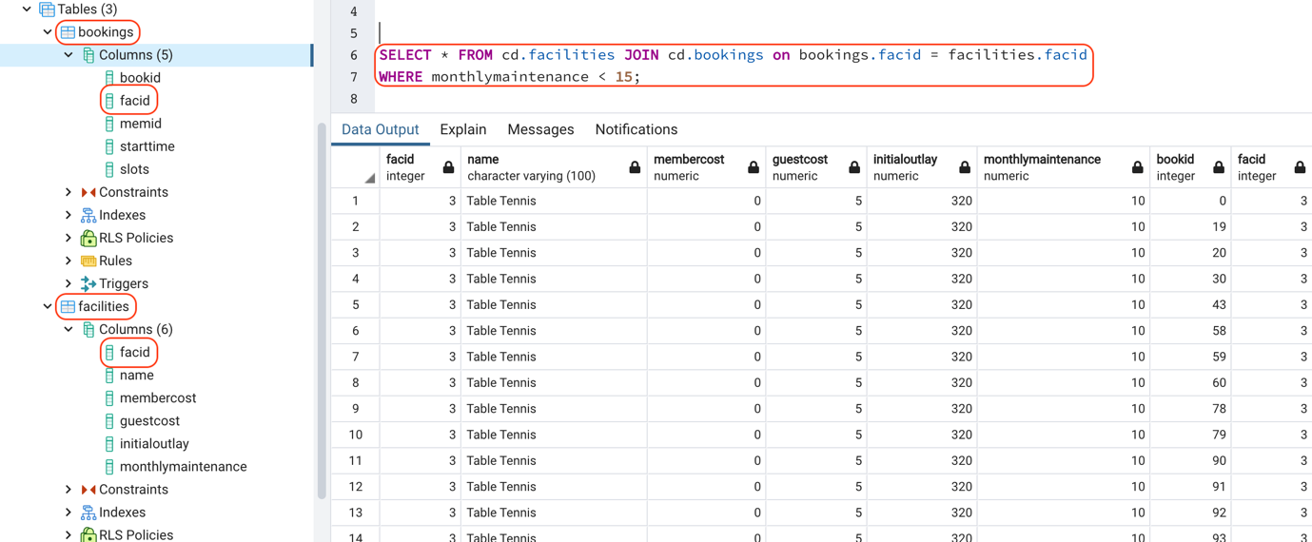



So, it will take all the facilities table and then it will JOIN with the first relation with the bookings table on this critieria.

which means, we take:

The facid from bookings should be equal to the facilities facid. Then we will have two facid's. It will be normal because it will be the common point.

We can also assume that facilities table has primary key "facid" and the bookings has a foreign key "facid".

In here, the select * from something "table" will give us some new relation on which we can filter using exactly the same rows.

* We can combine them only if they have a common point.
* What happens if they don't have a common point? Then
* We create NULL Entries on one or another side. Depending on the JOINT.

UPDATE the PATH if you get an error while doing

* SELECT * FROM bookings;
* OR
* SELECT * FROM cd.bookings

cd = schema name.

Venn Diagram is used to identify the populations and conditions for BOOLEAN logics.

The entire data of A and the intersection.

Duplicates create CARTISSIANS.

Find out more about the Cartesian.

EVALUATION EXERCISE

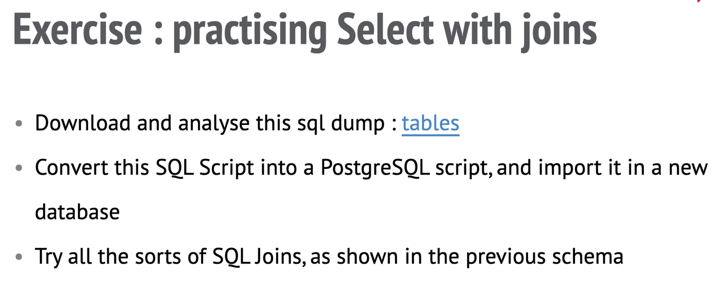

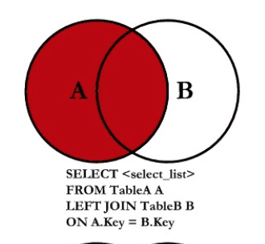

The null is the empty B. It's normal to have null.

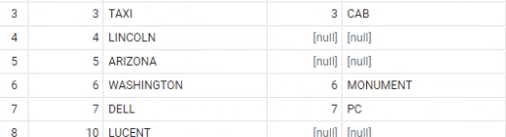

The case sensitivity is for the values . When you compare the values.

<https://pgexercises.com/questions/basic/>

### **Answers and Discussion Hide**

**select** * **from** cd.facilities;

The SELECT statement is the basic starting block for queries that read information out of the database. A minimal select statement is generally comprised of select [some set of columns] from [some table or group of tables].

In this case, we want all of the information from the facilities table. The from section is easy - we just need to specify the cd.facilities table. 'cd' is the table's schema - a term used for a logical grouping of related information in the database.

Next, we need to specify that we want all the columns. Conveniently, there's a shorthand for 'all columns' - *. We can use this instead of laboriously specifying all the column names.

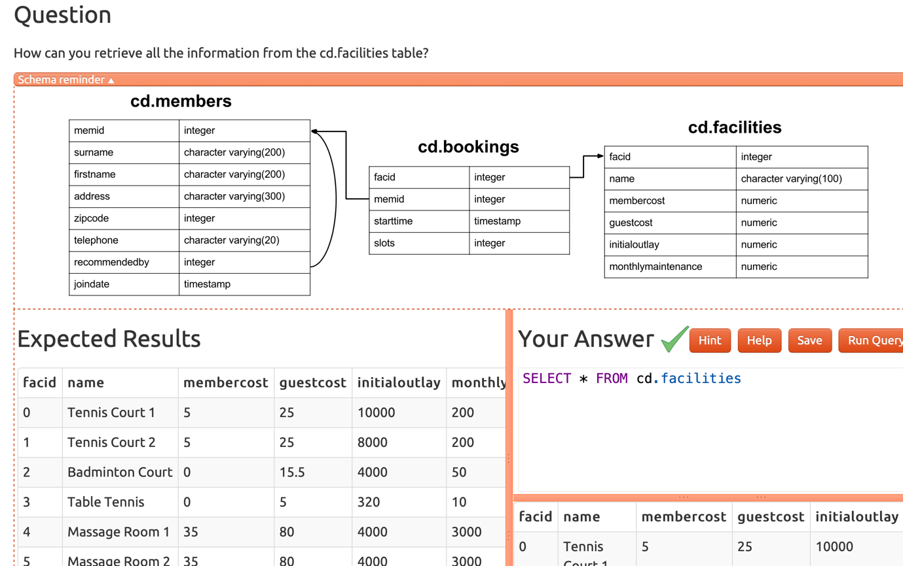

DISTINCT = Is used to remove the duplications.

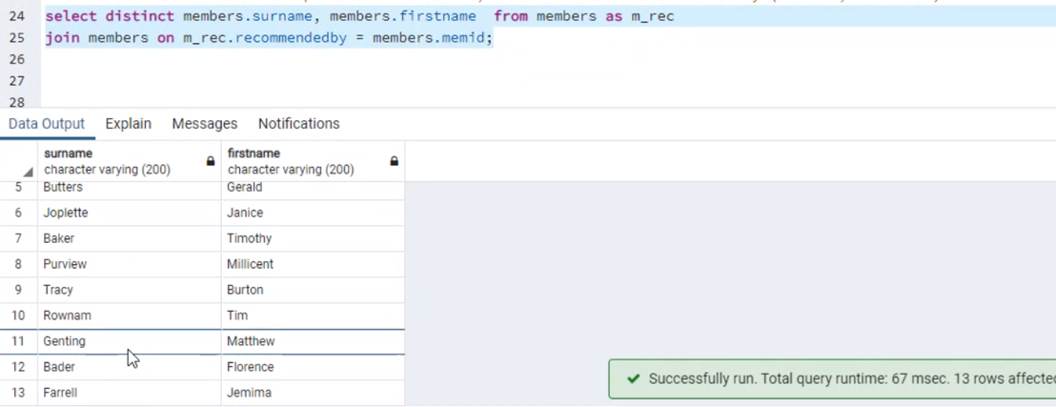

If you want to keep the data on the left. You use left join.

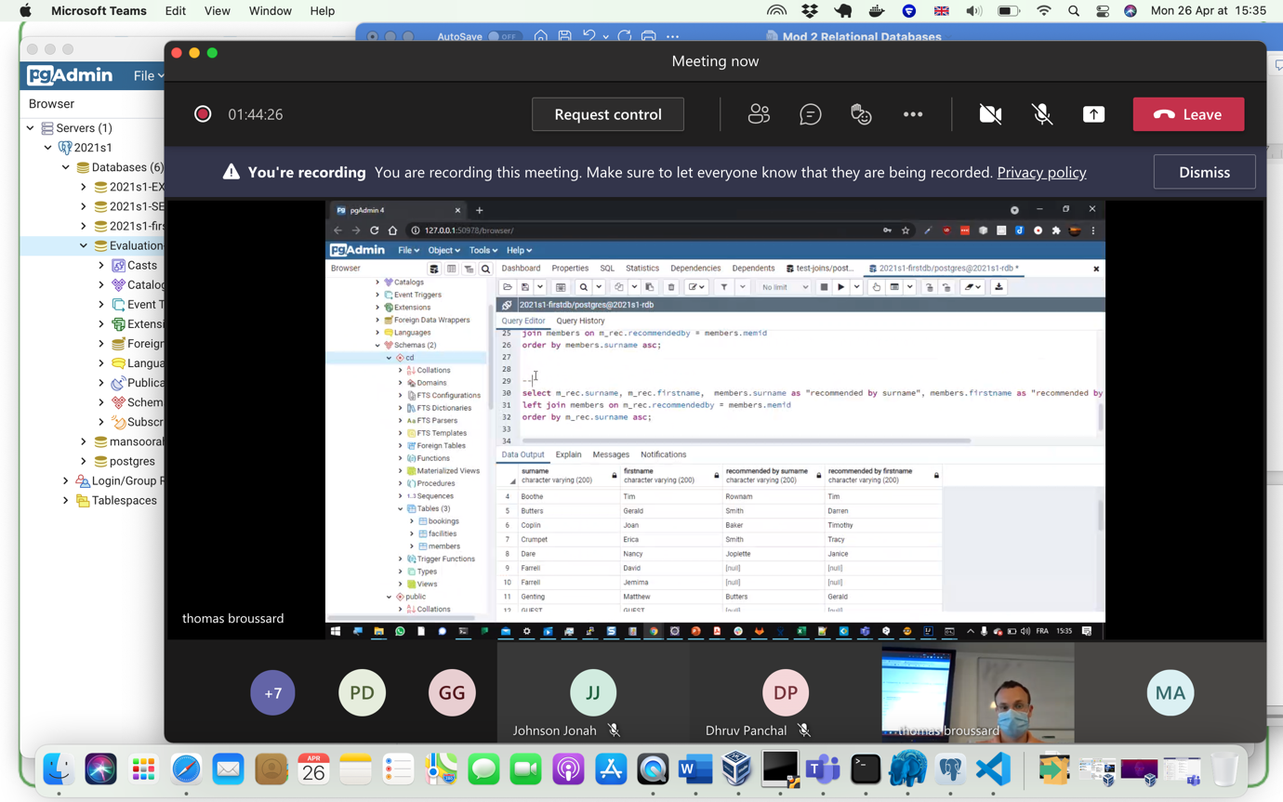



**Research:**

# **PostgreSQL Joins**

Kinds of PostgreSQL joins:

* Inner join
* Left join
* Right join
* Full outer join
* Self-join "Special Kind"

PostgreSQL join is used to combine columns from one ([self-join](https://www.postgresqltutorial.com/postgresql-self-join/)) or more tables based on the values of the common columns between related tables. The common columns are typically the [primary key](https://www.postgresqltutorial.com/postgresql-primary-key/) columns of the first table and [foreign key](https://www.postgresqltutorial.com/postgresql-foreign-key/) columns of the second table.

## Setting up sample tables

Suppose you have two tables called basket_a and basket_b that store fruits:

CREATE TABLE basket_a (

a INT PRIMARY KEY,

fruit_a VARCHAR (100) NOT NULL

);

CREATE TABLE basket_b (

b INT PRIMARY KEY,

fruit_b VARCHAR (100) NOT NULL

);

INSERT INTO basket_a (a, fruit_a)

VALUES

(1, 'Apple'),

(2, 'Orange'),

(3, 'Banana'),

(4, 'Cucumber');

INSERT INTO basket_b (b, fruit_b)

VALUES

(1, 'Orange'),

(2, 'Apple'),

(3, 'Watermelon'),

(4, 'Pear');

The tables have some common fruits such as apple and orange.

The following statement returns data from the basket_a table:

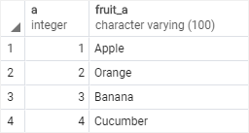

And the following statement returns data from the basket_b table:

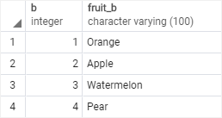

## PostgreSQL Left Join "Left-Outer-Join"

## Right Table Joins the Left Table

If the values are not equal in both tables, the left join clause creates a new row that contains columns that appear in the SELECT clause. In addition, it fills the columns that come from the right table with NULL.

The values that are not the common or the same in both table. Since the right table is joining the left table. The right sides rows will be shown as null if they are not common.

The following statement uses the left join clause to join the basket_a table with the basket_b table. In the left join context, the first table is called the left table and the second table is called the right table.

* 1st Table = Left
* 2nd Table = Right

COMMAND:

SELECT a1, fruit_a1, b1, fruit_b1 FROM basket_a LEFT JOIN basket_b ON fruit_a1 = fruit_b1;

SELECT

a1,

fruit_a1,

b1,

fruit_b1

FROM

basket_a

LEFT JOIN basket_b

ON fruit_a1 = fruit_b1;

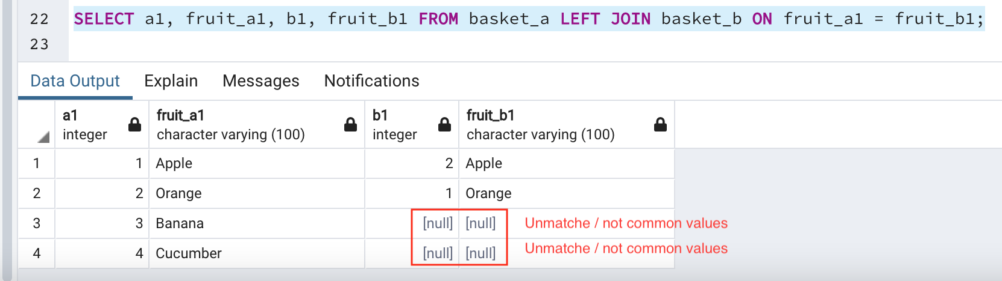

The left join starts selecting data from the left table. It compares values in the fruit_a1 column with the values in the fruit_b1 column in the basket_b table.

If these values are equal, the left join creates a new row that contains columns of both tables and adds this new row to the result set. (see the row #1 and #2 in the result set).

In case the values do not equal, the left join also creates a new row that contains columns from both tables and adds it to the result set. However, it fills the columns of the right table (basket_b) with null. (see the row #3 and #4 in the result set).

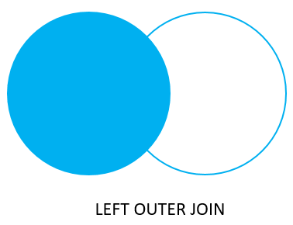

As, we can see in the picture as well. The right side is empty and blank. Un Matched values will be shown as NULL on the right table.

## PostgreSQL Right Join "Right-Outer-Join"

## Left Table Joins the Right Table

The [right join](https://www.postgresqltutorial.com/postgresql-right-join/) is a reversed version of the left join. The unmatched values on the left table will be shown as NULL. The right join starts selecting data from the right table. It compares each value in the fruit_b1 column of every row in the right table with each value in the fruit_a1 column of every row in the fruit_a1 table.

If these values are equal, the right join creates a new row that contains columns from both tables.

In case these values are not equal, the right join also creates a new row that contains columns from both tables. However, it fills the columns in the left table with NULL.

The following statement uses the right join to join the basket_a table with the basket_b table:

COMMAND:

SELECT a1, fruit_a1, b1, fruit_b1 FROM basket_a RIGHT JOIN basket_b ON fruit_a1 = fruit_b1;

SELECT

a1,

fruit_a1,

b1,

fruit_b1

FROM

basket_a

RIGHT JOIN basket_b ON fruit_a1 = fruit_b1;

Here is the output:

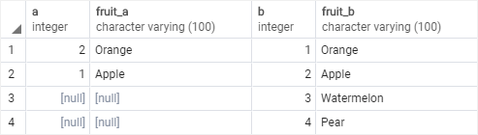



The following Venn diagram illustrates the right join:

It shows in the picture as well that the Left table has joined the right table, the common values will be shown correctly, but the uncommon and unmatched values will be shown as NULL on the left table.

The picture shows left table as blank and white.

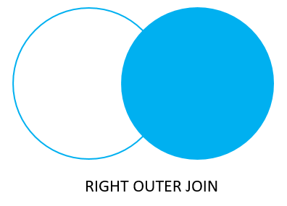

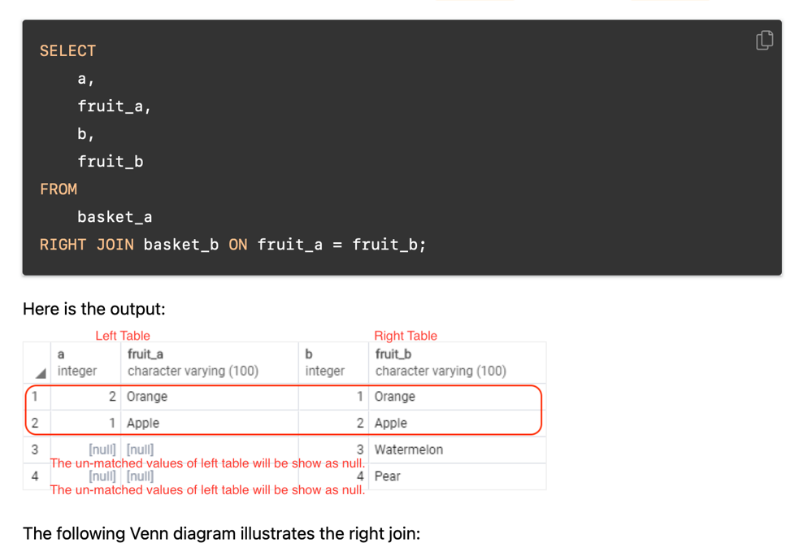

Introduction to PostgreSQL RIGHT JOIN clause

RIGHT OUTER JOIN clause - Exclusive

Similarly, you can join the two tables. The left table will join the right side. THE only difference is that we apply the WHERE or the CLAUSE which is the filter on the rows.

Similarly, you can get rows from the right table that do not have matching rows from the left table by adding a WHERE clause as follows:

SELECT

a1,

fruit_a1,

b1,

fruit_b1

FROM

basket_a

RIGHT JOIN basket_b

ON fruit_a1 = fruit_b1

WHERE a1 IS NULL;

Code language: SQL (Structured Query Language) (sql)

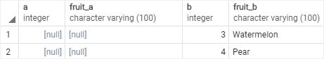

The RIGHT JOIN and RIGHT OUTER JOIN are the same therefore you can use them interchangeably.

The following Venn diagram illustrates the right join that returns rows from the right table that do not have matching rows in the left table:

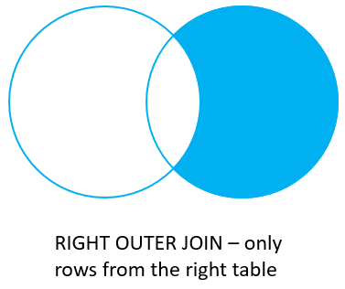

## PostgreSQL Full Outer Join

## JOIN LEFT & RIGHT DISPLAY NULLS ON LEFT & RIGHT

The [full outer join](https://www.postgresqltutorial.com/postgresql-full-outer-join/) or full join returns a result set that contains all rows from both left and right tables, with the matching rows from both sides if available. In case there is no match, the columns of the table will be filled with NULL.

SELECT

a1,

fruit_a1,

b1,

fruit_b1

FROM

basket_a

FULL OUTER JOIN basket_b

ON fruit_a1 = fruit_b1;

Code language: SQL (Structured Query Language) (sql)

Output:

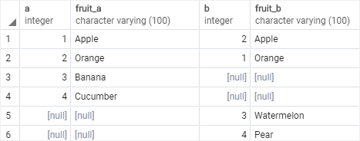

The following Venn diagram illustrates the full outer join:



To return rows in a table that do not have matching rows in the other, you use the full join with a WHERE clause like this:

SELECT

a1,

fruit_a1,

b1,

fruit_b1

FROM

basket_a

FULL JOIN basket_b

ON fruit_a1 = fruit_b1

WHERE a1 IS NULL OR b1 IS NULL;

Code language: SQL (Structured Query Language) (sql)

Here is the result:

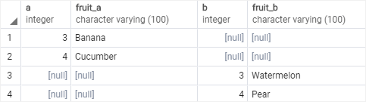

The following Venn diagram illustrates the full outer join that returns rows from a table that do not have the corresponding rows in the other table:

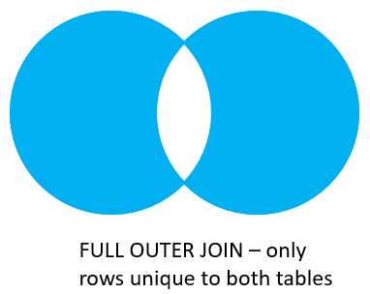

The following picture shows all the PostgreSQL joins that we discussed so far with the detailed syntax:

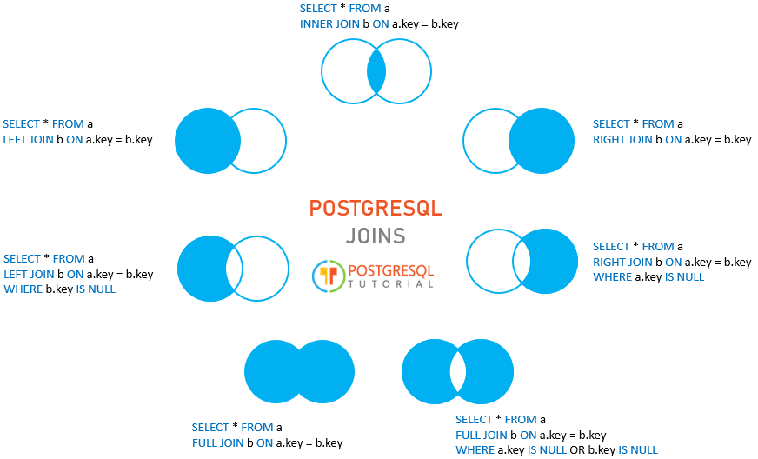

In this tutorial, you have learned how to use various kinds of PostgreSQL joins to combine data from multiple related tables.

IT shows all the data while using the left join because, we are joining the integer column "b1 to a1".

b1 = 1, 2, 3, 4 and a1 = 1, 2, 3, 4 of course, there are similarities.

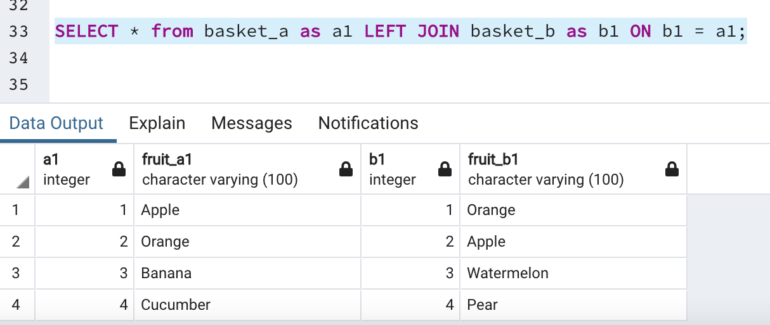

MOD - 5

Evoluation 2:

"we see a bad encoding. Fix it first"

It will show the most expensive product.

SELECT * FROM PRODUCT ORDER BY unit_price DESC LIMIT 1;

COMMAND:

SELECT * FROM products LEFT JOIN categories ON categories.category_id = products.category_id;

I would like to have the count of product pair category. It will be a group by instruction. I don't come from categories. I come from products.

How to count a number of product.

COMMAND:

Select count(*) from products;

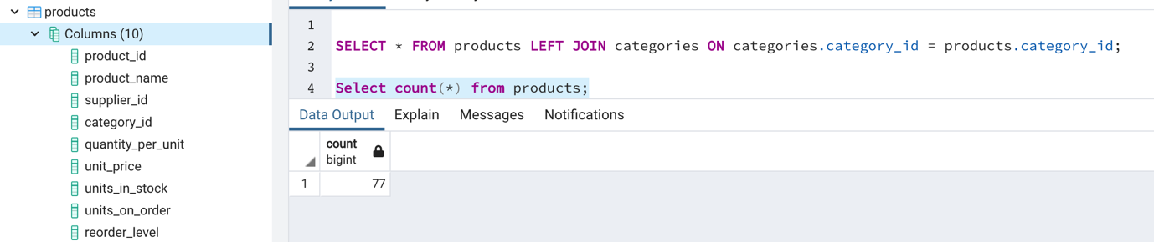

Select category_id, count(category_id) from products;

associate with the category_id

COMMAND:

Select categories.category_name, count(products.category_id) from products

join categories ON categories.category_id = products.category_id

group by products.category_id, categories.category_name

ORDER by categories.category_name;

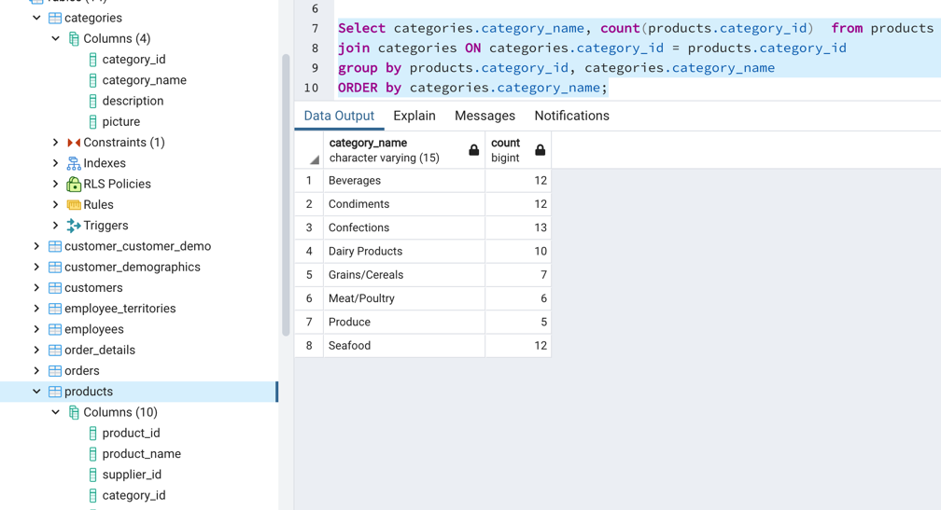

COMMAND:

SELECT distinct country from customers;

asc = alphabitically order

How can i count pair country?

COMMAND:

Select country, count(*) from customers GROUP BY country ORDER BY country asc;

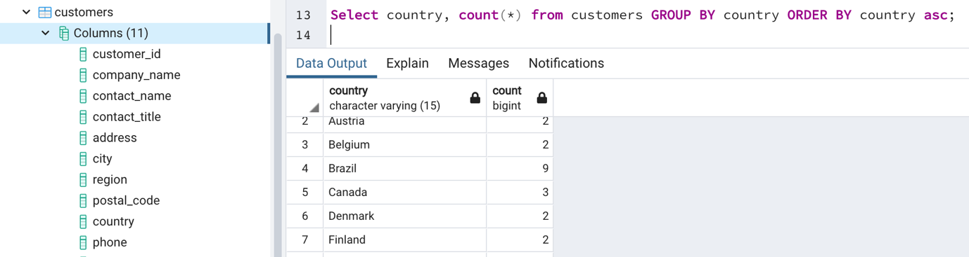

NOTE:

The main difficulty is to understand what to query against what you are asked.

To sum list of order_detail?

Sum of quantities.

COMMAND:

Select sum(quantity) from order_details;

LIST OF QUERRIES:

-- 10 most expensive products

-- list of discontinued products

-- list of products that have never been ordered?  
-- average order price

-- revenue per category  
-- number of orders per shipper

-- number of orders per region

-- total revenue per supplier

Mod -4

LEFT JOIN:

We will have all Table A and the correspondence of Table B. Data that has no correspondence or similarity will remain as blank or null.

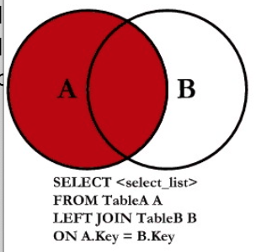

Intersection

The intersection means the correspondence. To use intersection the columns or the two set of columns that we are going to intersect must have the same data type.

To use the INTERSECT operator, the columns that appear in the SELECT statements must follow the folowing rules:

* The number of columns and their order in the SELECT clauses must be the same.
* The [data types](https://www.postgresqltutorial.com/postgresql-data-types/) of the columns must be compatible.

Example:

SELECT select_list "select_list = a column"

FROM A "Table A"

INTERSECT

SELECT select_list "select_list = a column"

FROM B; "Table B"

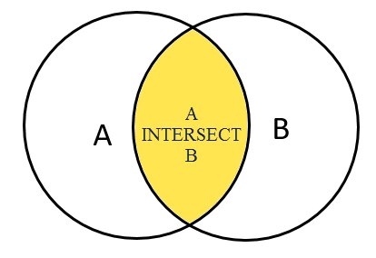

LEFT JOIN WHERE CLAUSE

* It's used when Table_A or source has no connection or correspondence with Table_B or Target table.
* Show the result of the rows of Table B where it does not correspond to any row in Table A.
* Show me the result of Table B that are only NULL. We do it with exclusion.

You would like to see the list of students "table" that are not linked to this course "table". If you want to have unassigned students to any course, Left Join with Where Clause can apply.

-- Left join with exclusion of Where clause

SELECT * FROM TABLE_A as A LEFT JOIN TABLE_B as B ON b.pk = a.pk WHERE b.pk is NULL;

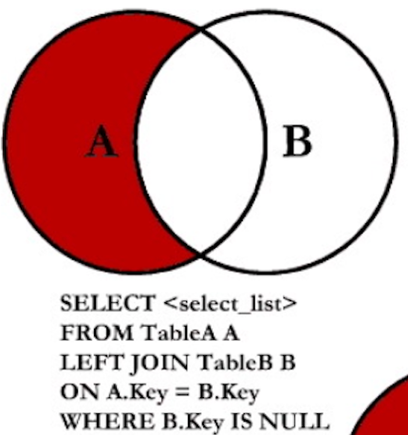



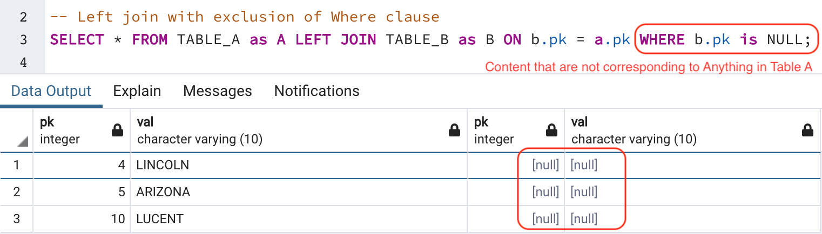

Where B.Key IS NULL, means there is no reference. This can apply to a situation where you want to identify broken links. Like students and courses.

To join the table A with the table B table using a left join, you follow these steps:

1. First, specify the columns in both tables from which you want to select data in the SELECTclause.
2. Second, specify the left table (table A) in the FROM clause.
3. Third, specify the right table (table B) in the LEFT JOIN clause and the join condition after the ON keyword.

**PRACTICE**

SQL - Tables - Test - Joins

Import the SQL table provided by the professor. Fix the variables issue. Perform queries.

* SELECT * FROM TABLE_A;
* SELECT * FROM TABLE_B;

SQL JOINS:

What do you notice in these tables?

* The table column name is PK.
* We can see multiple one values, which can't be the primary keys.
* The constraint section is empty. No primary or foreign keys.
* Both tables A and B have the same column names.

We should notice everything.

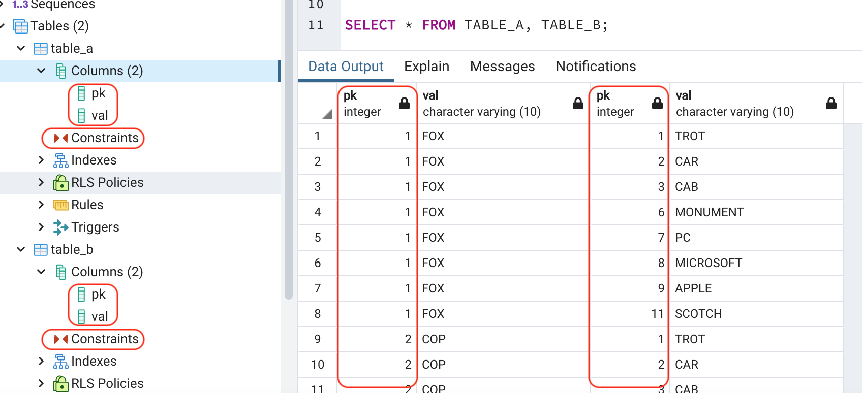

JOIN WITHOUT PRIMAY KEYS:

* Joining two tables without any primary key.
* To join to tables without primary keys and foreign keys, we must make sure that there is only one target in the remote table "exact remote spot."
* We will have duplicates.
* That will be the impact.

Example:

If one row in table-A has 3 equivalence rows in table-B. We will have 3 times this row from table-A that will appear in the relevance.

* This is called a cartesian product.
* If your JOINT in source and target are not unique. It will create duplication.
* The result will be a bad JOINT.
* It will be size of A * size of B.

EXERCISE OF CARTESIAN PRODUCT:

SELECT * FROM TABLE_A as A LEFT JOIN TABLE_B as B ON b.pk = b.pk;

* It's a cartesian product.
* We are joining and duplicating a column. Table is going to be listed twice.
* Multiple rows for everything
* 8 rows each. It's 8 * 8 which is 64. Each row of A displayed B times.

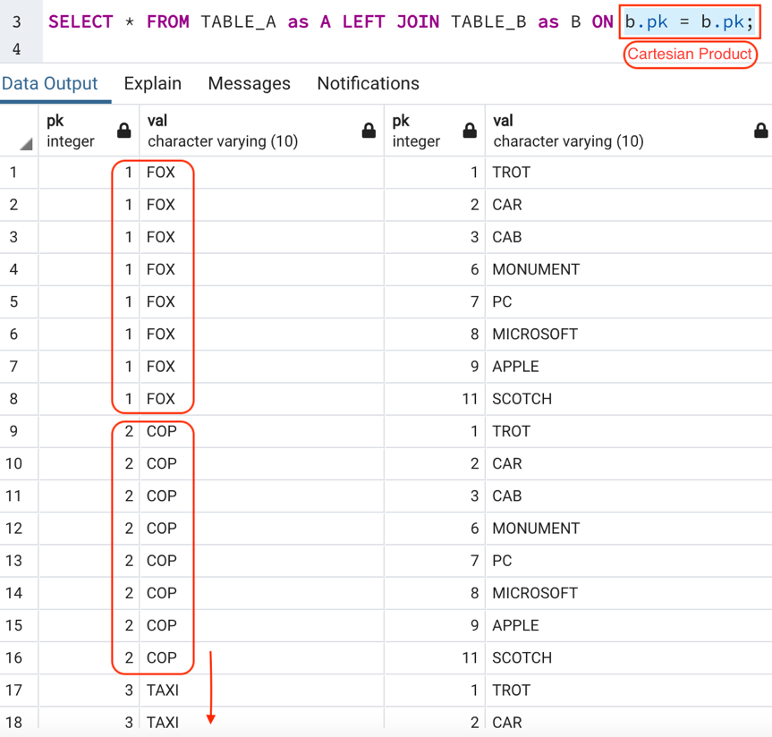

EXERCISE OF JOINS:

* We are corresponding the table A and B based on similarities of the PK columns.
* Alias = TABLE_A as A
* Alias = TABLE_B as B
* Alias = b.pk "table_b, column pk"
* Alias = a.pk "table_a column pk"

--left join:

SELECT * FROM TABLE_A as A LEFT JOIN TABLE_B as B ON b.pk = a.pk;

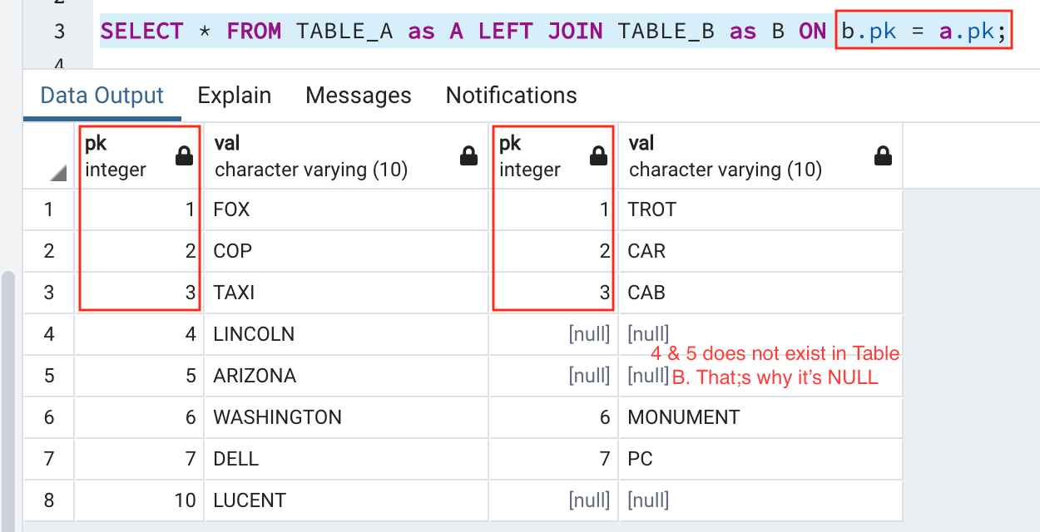

* Data that are only in A in ID form inside pk = 4, 5 and 10 which are not in table B.
* No equivalence in table B.

EXERCISE OF FULL OUTER JOIN

Join everything from one table into another table even if it has NULL rows or values.

* We want all the data from Table A.
* We want all the data from Table B.

-- full outer join.

SELECT * FROM TABLE_A as A FULL OUTER JOIN TABLE_B as B ON a.pk = b.pk;

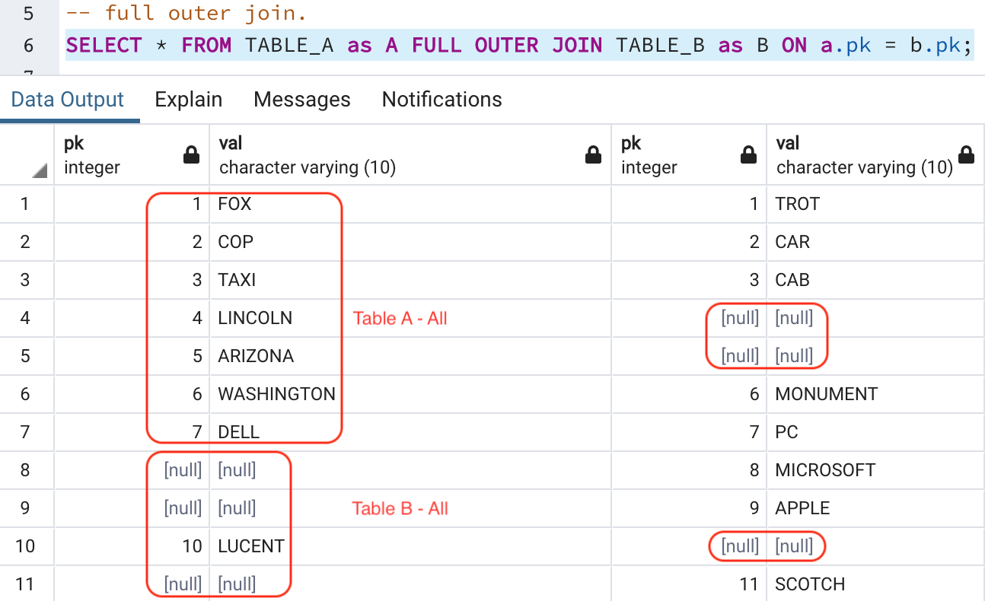

* We have everything. Such as
* Data that exist only in B, which are NULL
* Data exist only in A, which are NULL as well.
* We have everything.

### **ORDER BY clause**

When you query data from a table, the SELECT statement returns rows in an unspecified order. To sort the rows of the result set, you use the ORDER BY clause in the SELECT statement.

* The ORDER BY clause allows you to sort rows returned by a SELECT clause in ascending or descending order based on a sort expression.

SELECT

select_list "ONE-column"

FROM

table_name "ONE table"

ORDER BY

sort_expression1 [ASC | DESC],

...

sort_expressionN [ASC | DESC];

* OR Multiple columns, but separated by a COMMA.
* First, specify a sort expression, which can be a column or an expression, that you want to sort after the ORDER BY keywords. If you want to sort the result set based on multiple columns or expressions, you need to place a comma (,) between two columns or expressions to separate them.
* Second, you use the ASC option to sort rows in ascending order and the DESC option to sort rows in descending order. If you omit the ASC or DESC option, the ORDER BY uses ASC by default.

Example of customer table.

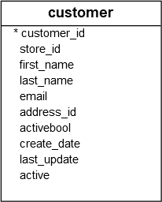ORDER EXAMPLE:



SELECT

first_name,

last_name

FROM



customer

ORDER BY

first_name ASC;



Output:  
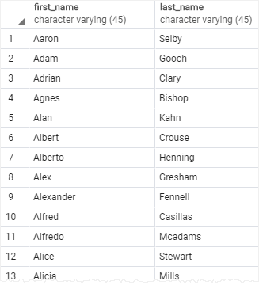



OR, order firstname in ASC and lastname in DESC.

SELECT

first_name,

last_name

FROM

customer

ORDER BY

first_name ASC, "Order firstname in ASC"

last_name DESC; "Order lastname in DESC"

**Column Alias**

A column alias allows you to assign a column or an expression in the select list of a SELECTstatement a temporary name. The column alias exists temporarily during the execution of the query.

SELECT column_name AS alias_name

FROM table_name;

* AS is optional.
* We can omit it.

SELECT column_name alias_name

FROM table_name;

EXAMPLE of COLUMN ALIAS:

If you want to rename the last_name heading, you can assign it a new name using a column alias like this:



SELECT

first_name,

last_name AS surname

FROM customer;

* This query assigned the surname as the alias of the last_name column:

OUTPUT

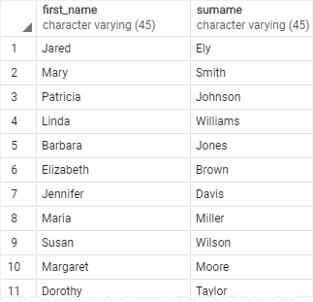



PG-EXERCISES:

Question-1: How can you produce a list of the start time for bookings by members named 'David Farell'?

* What do we want?
* 1) We want the bookings table and start time column.
* Why should we join?
* If we only have to display the start time from bookings?
* Because, we have to filter the firstname and surname through the relationship.

Method-1:

SELECT * FROM cd.members as m WHERE m.firstname = 'David';

--Problem

SELECT * FROM cd.members as m WHERE m.firstname = 'David' AND m.surname = 'Farell';

--The same exercise using join: output is empty start time.

SELECT b.starttime FROM cd.bookings as b join cd.members as m ON m.memid = b.memid

WHERE m.firstname = 'David' AND m.surname = 'Farell';

EVALUATION:

Question-2: How can you produce a list of the start times for bookings for tennis courts, for the date "2012-09-21" Return a list of start time and facility name pairing, ordered by the time.

* What do we want?
* 1) We want the bookings table with start times column.
* We want the stat time column and facility name similar pairing.
* We want to show it in ordered by the time.

SELECT b.starttime, f."name" FROM cd.bookings as b JOIN cd.facilities as f ON f.facid = b.facid

WHERE f."name" in ('Tennis Court 1', 'Tennis Court 2')

AND b.starttime >= '2012-09-21'

AND b.starttime < '2012-09-22'

ORDER BY b.starttime DESC;

Question-3: How can you output a list of all members who have recommended another member? Ensure that there are no duplicates in the list, and that results are ordered by (surname, firstname).

* What do we want?
* List of all the recommended by another member
* List of people who have recommended other people.
* We will need to join "JOIN ITSELF" to find
* People who are not recommended by anyone, will not be shown because of the join.

COMMAND:

SELECT cd.members.surname, cd.members.firstname

FROM cd.members as Mansoor_alias

JOIN cd.members ON Mansoor_alias.recommendedby = cd.members.memid

ORDER BY surname ASC;

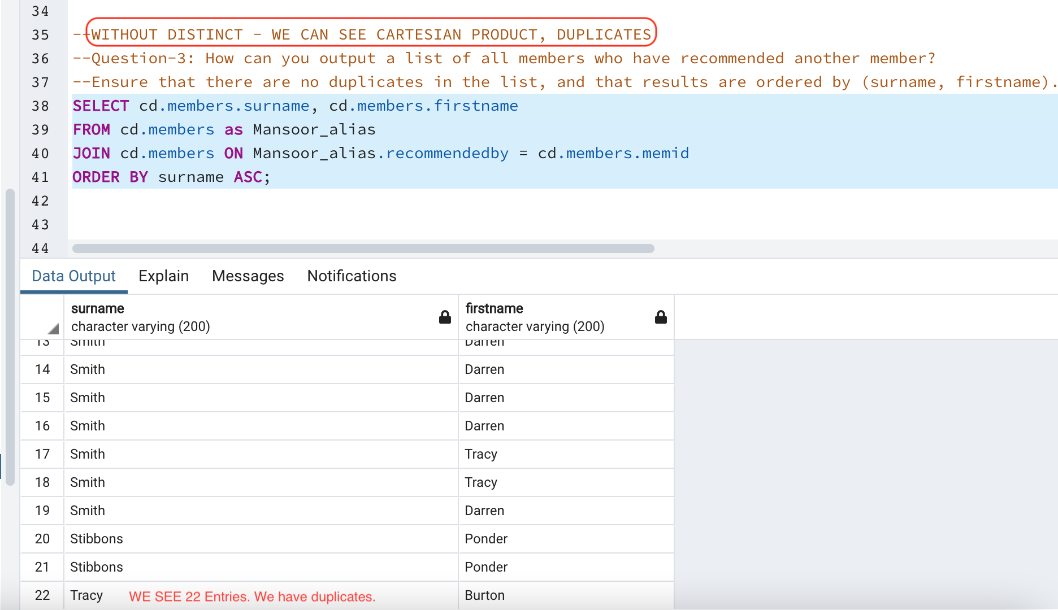

TO SOLVE THE DUPLICATES: We can have a unique list.

SELECT DISTINCT cd.members.surname, cd.members.firstname

FROM cd.members as Mansoor_alias

JOIN cd.members ON Mansoor_alias.recommendedby = cd.members.memid

ORDER BY surname ASC;

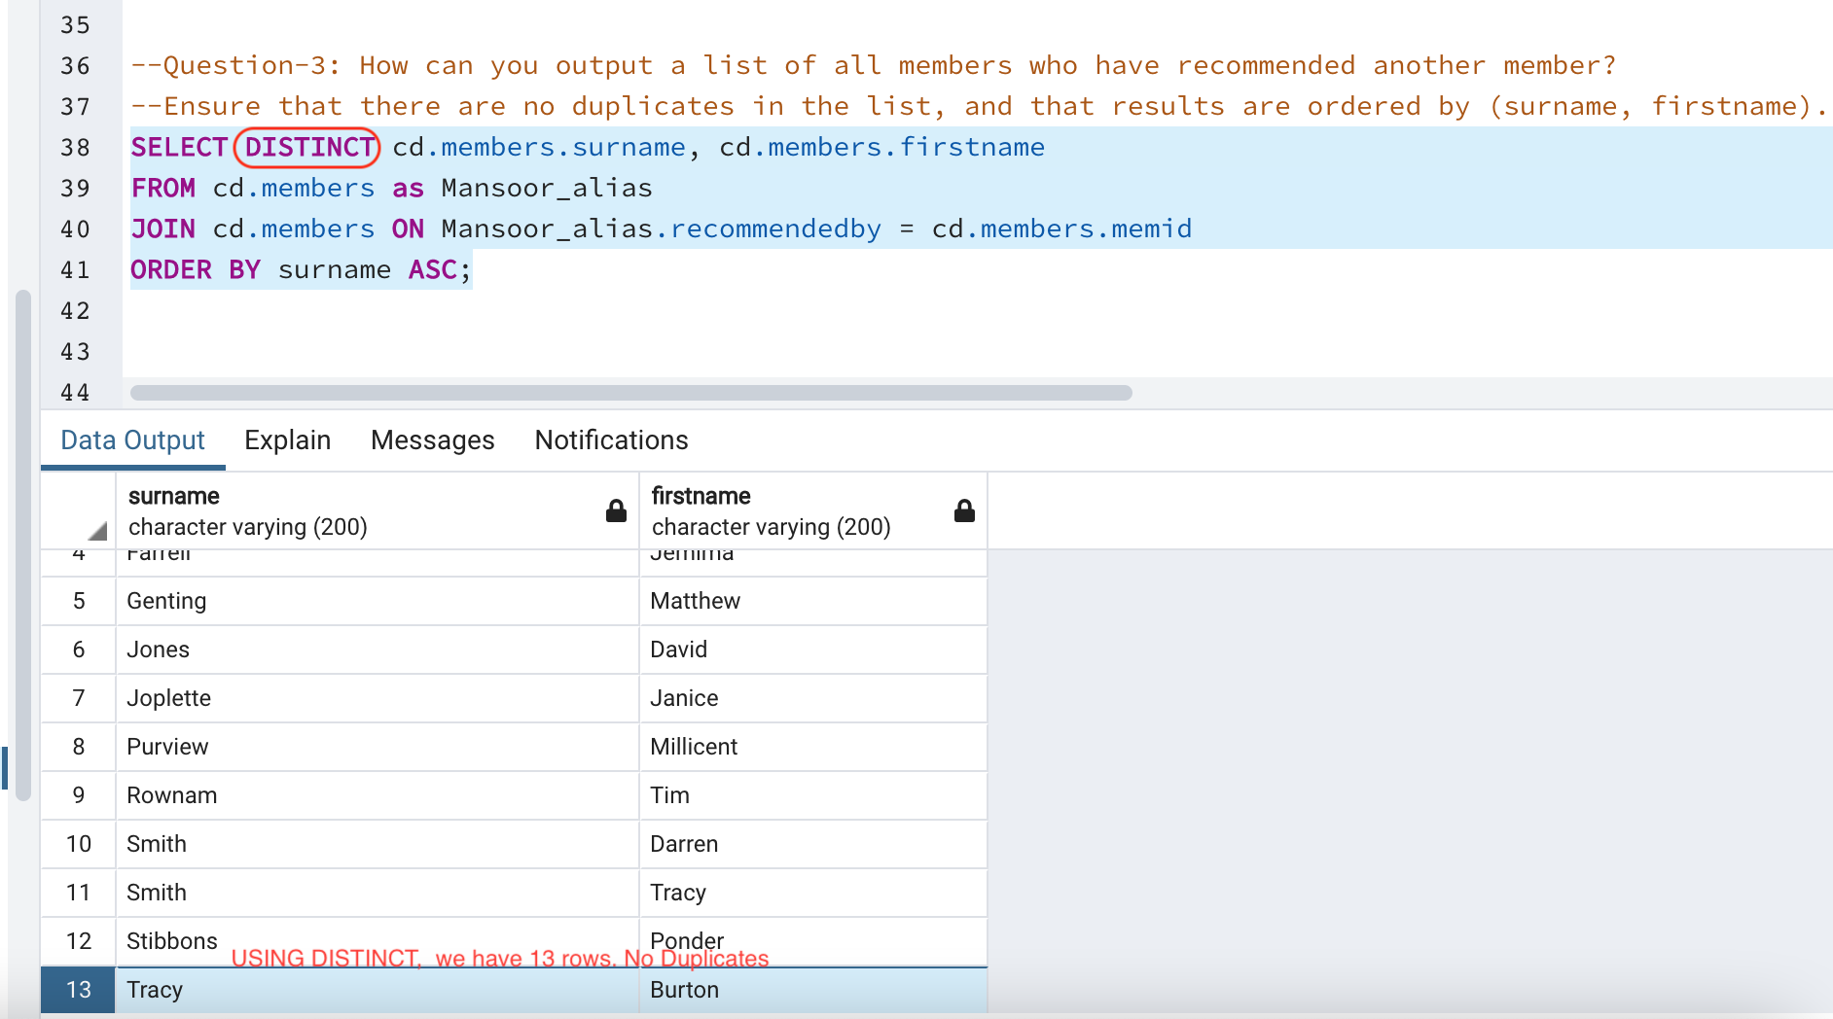

--how can I write without an Alias? It doesn't work

SELECT cd.members.memid, cd.members.surname, cd.members.firstname,

cd.members.recommendedby FROM cd.members

JOIN cd.members ON cd.members.recommendedby = cd.members.memid;

**JOIN - or - SELF JOIN**

Join is used to combine columns from one ([self-join](https://www.postgresqltutorial.com/postgresql-self-join/)) or more tables based on the values of the common columns between related tables.

The common columns are typically the [primary key](https://www.postgresqltutorial.com/postgresql-primary-key/) columns of the first table and [foreign key](https://www.postgresqltutorial.com/postgresql-foreign-key/) columns of the second table

**DISTINCT**

It will remove the duplicates that comes from the JOIN.

SELECT DISTINCT clause to remove duplicate rows from a result set returned by a query.

The DISTINCT clause is used in the [SELECT](https://www.postgresqltutorial.com/postgresql-select/) statement to remove duplicate rows from a result set.

The DISTINCT clause keeps one row for each group of duplicates. The DISTINCTclause can be applied to one or more columns in the select list of the SELECT statement.

EXAMPLE - ONE COLIMN:

SELECT

DISTINCT column1

FROM

table_name;

EXAMPLE - TWO COLIMN:

SELECT

DISTINCT column1, column2

FROM

table_name;

* In this case, the combination of values in both column1 and column2 columns will be used for evaluating the duplicate.

Video

01 hour

24 min

30 seconds

### **Question-2**

2. How can you produce a list of facilities that charge a fee to members?

**select** * **from** cd.facilities **where** membercost > 0;

### **Question-3**

How can you produce a list of facilities that charge a fee to members, and that fee is less than 1/50th of the monthly maintenance cost? Return the facid, facility name, member cost, and monthly maintenance of the facilities in question.

select facid, name, membercost, monthlymaintenance from cd.facilities where membercost > 25;

OR

**select** facid, name, membercost, monthlymaintenance **from** cd.facilities **where** membercost > 0 **and** (membercost < monthlymaintenance/50.0);

The WHERE clause allows us to filter for the rows we're interested in - in this case, those with a membercost of more than zero, and less than 1/50th of the monthly maintenance cost. As you can see, the massage rooms are very expensive to run thanks to staffing costs!

When we want to test for two or more conditions, we use AND to combine them. We can, as you might expect, use OR to test whether either of a pair of conditions is true.

You might have noticed that this is our first query that combines a WHERE clause with selecting specific columns. You can see in the image below the effect of this: the intersection of the selected columns and the selected rows gives us the data to return. This may not seem too interesting now, but as we add in more complex operations like joins later, you'll see the simple elegance of this behaviour.

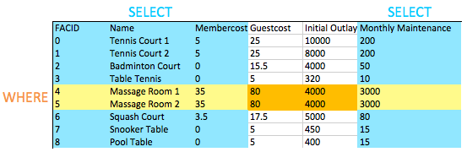

Basic string searches

Basic String Searches

### **Question-4**

How can you produce a list of all facilities with the word 'Tennis' in their name?

Select * from cd.facilities where name like '%Tennis%';

**select** * **from** cd.facilities **where** name **like** '%Tennis%';

SQL's LIKE operator provides simple pattern matching on strings. It's pretty much universally implemented, and is nice and simple to use - it just takes a string with the % character matching any string, and _ matching any single character. In this case, we're looking for names containing the word 'Tennis', so putting a % on either side fits the bill.

There's other ways to accomplish this task: Postgres supports regular expressions with the ~operator, for example. Use whatever makes you feel comfortable, but do be aware that the LIKEoperator is much more portable between systems.

LIKE Operator

Suppose that you want to find a customer but you do not remember her name exactly. However, you just remember that her name begins with something like Jen.

You can use the PostgreSQL LIKE operator to match the first name of the customer with a string like this query:

SELECT

first_name,

last_name

FROM

customer

WHERE

first_name LIKE 'Jen%';

ORDER BY "If necessary"

first_name;

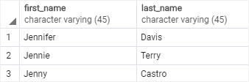

Notice that the WHERE clause contains a special expression: the first_name, the LIKE operator and a string that contains a percent sign (%). The string 'Jen%' is called a pattern

Matching Against Multiple Possible Values

### **Question-5**

How can you retrieve the details of facilities with ID 1 and 5? Try to do it without using the ORoperator.

**select** * **from** cd.facilities **where** facid **in** (1,5);

The obvious answer to this question is to use a WHERE clause that looks like where facid = 1 or facid = 5. An alternative that is easier with large numbers of possible matches is the INoperator. The IN operator takes a list of possible values, and matches them against (in this case) the facid. If one of the values matches, the where clause is true for that row, and the row is returned.

The IN operator is a good early demonstrator of the elegance of the relational model. The argument it takes is not just a list of values - it's actually a table with a single column. Since queries also return tables, if you create a query that returns a single column, you can feed those results into an IN operator. To give a toy example:

IN Operator

You use IN operator in the [WHERE](https://www.postgresqltutorial.com/postgresql-where/) clause to check if a value matches any value in a list of values.

The IN operator returns true if the value matches any value in the list i.e., value1 , value2 , …

The list of values can be a list of literal values such as numbers, strings or a result of a SELECT

## IN Operator Examples

SELECT customer_id, "column"

rental_id, "column"

return_date "column"

FROM

rental "Table"

WHERE

customer_id IN (1, 2);

ORDER BY "If needed"

return_date DESC;

IN | OR Operation

The following query uses the equal (=) and OR operators instead of the IN operator. It is equivalent to the query above:

SELECT

rental_id,

customer_id,

return_date

FROM

rental

WHERE

customer_id = 1 OR customer_id = 2

The query that uses the IN operator is shorter and more readable than the query that uses equal (=) and OR operators. In addition, PostgreSQL executes the query with the IN operator much faster than the same query that uses a list of OR operators.

## NOT IN operator

You can combine the IN operator with the NOT operator to select rows whose values do not match the values in the list.

Example, the following statement finds all rentals with the customer id is not 1 or 2.

SELECT

customer_id, "column"

rental_id, "column"

return_date "column"

FROM

rental

WHERE

customer_id NOT IN (1, 2);

Classify Results into Buckets

### **Question-5**

How can you produce a list of facilities, with each labelled as 'cheap' or 'expensive' depending on if their monthly maintenance cost is more than $100? Return the name and monthly maintenance of the facilities in question.

**select** name, **case** **when** (monthlymaintenance > 100) **then** 'expensive' **else** 'cheap' **end** **as** cost **from** cd.facilities;

select name,

case when (monthlymaintenance > 100)

then

'expensive'

else

'cheap'

end as cost from cd.facilities;

This exercise contains a few new concepts. The first is the fact that we're doing computation in the area of the query between SELECT and FROM. Previously we've only used this to select columns that we want to return, but you can put anything in here that will produce a single result per returned row - including subqueries.

The second new concept is the CASE statement itself.  CASE is effectively like if/switch statements in other languages, with a form as shown in the query. To add a 'middling' option, we would simply insert another when...then section.

Finally, there's the AS operator. This is simply used to label columns or expressions, to make them display more nicely or to make them easier to reference when used as part of a subquery.

# **Working with Dates**

### **Question-6**

How can you produce a list of members who joined after the start of September 2012? Return the memid, surname, firstname, and joindate of the members in question.

select memid, surname, firstname, joindate from cd.members where joindate >= '2012/09/01';

**select** memid, surname, firstname, joindate **from** cd.members **where** joindate >= '2012-09-01';

This is our first look at SQL timestamps. They're formatted in descending order of magnitude: YYYY-MM-DD HH:MM:SS.nnnnnn. We can compare them just like we might a unix timestamp, although getting the differences between dates is a little more involved (and powerful!). In this case, we've just specified the date portion of the timestamp. This gets automatically cast by postgres into the full timestamp 2012-09-01 00:00:00.

# **Removing Duplicates, and Ordering Results**

### **Question**

How can you produce an ordered list of the first 10 surnames in the members table? The list must not contain duplicates.

select DISTINCT surname from cd.members order by surname ASC LIMIT 10;

**select** **distinct** surname **from** cd.members **order** **by** surname limit 10;

There's three new concepts here, but they're all pretty simple.

* Specifying DISTINCT after SELECT removes duplicate rows from the result set. Note that this applies to *rows*: if row A has multiple columns, row B is only equal to it if the values in all columns are the same. As a general rule, don't use DISTINCT in a willy-nilly fashion - it's not free to remove duplicates from large query result sets, so do it as-needed.
* Specifying ORDER BY (after the FROM and WHERE clauses, near the end of the query) allows results to be ordered by a column or set of columns (comma separated).
* The LIMIT keyword allows you to limit the number of results retrieved. This is useful for getting results a page at a time, and can be combined with the OFFSET keyword to get following pages. This is the same approach used by MySQL and is very convenient - you may, unfortunately, find that this process is a little more complicated in other DBs.

# **Combining Results from Multiple Queries**

### **Question**

You, for some reason, want a combined list of all surnames and all facility names. Yes, this is a contrived example :-). Produce that list!

You will learn how to use **PostgreSQL UNION** operator to combine result sets of multiple queries into a single result sets.

select surname from cd.members UNION select name from cd.facilities;

**select** surname **from** cd.members **union** **select** name **from** cd.facilities;

The UNION operator does what you might expect: combines the results of two SQL queries into a single table. The caveat is that both results from the two queries must have the same number of columns and compatible data types.

UNION removes duplicate rows, while UNION ALL does not. Use UNION ALL by default, unless you care about duplicate results.

The UNION operator combines result sets of two or more [SELECT](https://www.postgresqltutorial.com/postgresql-select/) statements into a single result set.

The following illustrates the syntax of the UNION operator that combines result sets from two queries:

SELECT column

FROM table_A

UNION

SELECT column

FROM table_B;

# **Simple Aggregation**

### **Question**

You'd like to get the signup date of your last member. How can you retrieve this information?

select max(joindate) from cd.members;

**select** max(joindate) **as** latest **from** cd.members;

This is our first foray into SQL's aggregate functions. They're used to extract information about whole groups of rows, and allow us to easily ask questions like:

* What's the most expensive facility to maintain on a monthly basis?
* Who has recommended the most new members?
* How much time has each member spent at our facilities?

The MAX aggregate function here is very simple: it receives all the possible values for joindate, and outputs the one that's biggest. There's a lot more power to aggregate functions, which you will come across in future exercises.

How to use the PostgreSQL MAX() function to get the maximum value of a set.

## Introduction to PostgreSQL MAX function

PostgreSQL  MAX function is an [aggregate function](https://www.postgresqltutorial.com/postgresql-aggregate-functions/) that returns the maximum value in a set of values. The MAX function is useful in many cases. For example, you can use the MAX function to find the employees who have the highest salary or to find the most expensive products, etc.

## MAX function examples

The following query uses the MAX() function to find the highest amount paid by customers in the payment table:

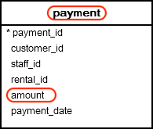

SELECT MAX(amount) "column"

FROM payment; "table"

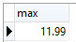

More Aggregation

### **Question**

You'd like to get the first and last name of the last member(s) who signed up - not just the date. How can you do that?

select firstname, surname, joindate from cd.members where joindate = (select max(joindate) from cd.members);

**select** firstname, surname, joindate **from** cd.members **where** joindate = (**select** max(joindate) **from** cd.members);

In the suggested approach above, you use a *subquery* to find out what the most recent joindate is. This subquery returns a *scalar* table - that is, a table with a single column and a single row. Since we have just a single value, we can substitute the subquery anywhere we might put a single constant value. In this case, we use it to complete the WHERE clause of a query to find a given member.

As mentioned by the hint, there's other ways to get this job done - one example is below. In this approach, rather than explicitly finding out what the last joined date is, we simply order our members table in descending order of join date, and pick off the first one. Note that this approach does not cover the extremely unlikely eventuality of two people joining at the exact same time :-).

IT WORKS PERFECTLY FINE.

**select** firstname, surname, joindate **from** cd.members **order** **by** joindate **desc** limit 1;

GITHUB: <https://github.com/tpaschalis/PostgreSQL-practice>

# **Retrieve the Start-times of Members' Bookings**

### **Question**

How can you produce a list of the start times for bookings by members named 'David Farrell'?

Method-1:

select bks.starttime from cd.bookings as bks, cd.members as mems

where

mems.firstname='David' and

mems.surname='Farrell' and

mems.memid = bks.memid;

Method-2:

select bks.starttime from cd.bookings as bks inner join cd.members as mems

on mems.memid = bks.memid

where mems.firstname = 'David' and mems.surname = 'Farrell';

The most commonly used kind of join is the INNER JOIN. What this does is combine two tables based on a join expression - in this case, for each member id in the members table, we're looking for matching values in the bookings table. Where we find a match, a row combining the values for each table is returned. Note that we've given each table an *alias* (bks and mems). This is used for two reasons: firstly, it's convenient, and secondly we might join to the same table several times, requiring us to distinguish between columns from each different time the table was joined in.

Let's ignore our select and where clauses for now, and focus on what the FROM statement produces. In all our previous examples, FROM has just been a simple table. What is it now? Another table! This time, it's produced as a composite of bookings and members. You can see a subset of the output of the join below:

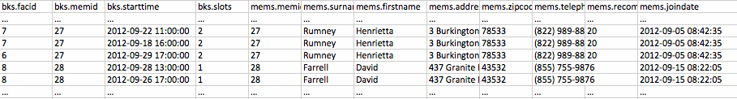

For each member in the members table, the join has found all the matching member ids in the bookings table. For each match, it's then produced a row combining the row from the members table, and the row from the bookings table.

Obviously, this is too much information on its own, and any useful question will want to filter it down. In our query, we use the start of the SELECT clause to pick columns, and the WHERE clause to pick rows, as illustrated below:

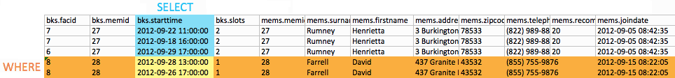

That's all we need to find David's bookings! In general, I encourage you to remember that the output of the FROM clause is essentially one big table that you then filter information out of. This may sound inefficient - but don't worry, under the covers the DB will be behaving much more intelligently :-).

One final note: there's two different syntaxes for inner joins. I've shown you the one I prefer, that I find more consistent with other join types. You'll commonly see a different syntax, shown below:

**select** bks.starttime

**from**

cd.bookings bks,

cd.members mems

**where**

mems.firstname='David'

**and** mems.surname='Farrell'

**and** mems.memid = bks.memid;

This is functionally exactly the same as the approved answer. If you feel more comfortable with this syntax, feel free to use it!

## Introduction to PostgreSQL INNER JOIN clause

In a relation database, data is typically distributed in more than one table. To select complete data, you often need to query data from multiple tables.

In this tutorial, we are focusing on how to combine data from multiple tables using the INNER JOIN clause.

Suppose that you have two tables A and B. The table A has a column pka whose value matches with values in the fka column of table B.

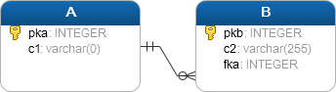

To select data from both tables, you use the INNER JOIN clause in the [SELECT](https://www.postgresqltutorial.com/postgresql-select/) statement as follows:

# **Work Out the Start-times of Bookings for Tennis Courts**

### **Question**

How can you produce a list of the start times for bookings for tennis courts, for the date '2012-09-21'? Return a list of start time and facility name pairings, ordered by the time.

# **Produce a List of All Members Who Have Recommended Another Member**

### **Question**

How can you output a list of all members who have recommended another member? Ensure that there are no duplicates in the list, and that results are ordered by (surname, firstname).

select distinct recs.firstname as firstname,

recs.surname as surname from cd.members as mems

inner join cd.members as recs on

recs.memid = mems.recommendedby

order by surname, firstname;

**select** **distinct** recs.firstname **as** firstname, recs.surname **as** surname

**from**

cd.members mems

**inner** **join** cd.members recs

**on** recs.memid = mems.recommendedby

**order** **by** surname, firstname;

Here's a concept that some people find confusing: you can join a table to itself! This is really useful if you have columns that reference data in the same table, like we do with recommendedby in cd.members.

If you're having trouble visualising this, remember that this works just the same as any other inner join. Our join takes each row in members that has a recommendedby value, and looks in members again for the row which has a matching member id. It then generates an output row combining the two members entries. This looks like the diagram below:

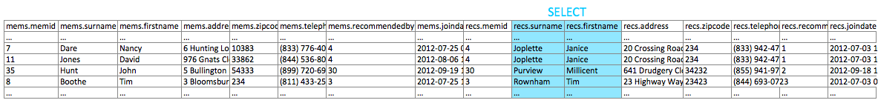

Note that while we might have two 'surname' columns in the output set, they can be distinguished by their table aliases. Once we've selected the columns that we want, we simply use DISTINCT to ensure that there are no duplicates.

# **Produce a List of All Members, Along with their Recommender**

### **Question**

How can you output a list of all members, including the individual who recommended them (if any)? Ensure that results are ordered by (surname, firstname).

select mems.firstname as memfname, mems.surname as memsname, recs.firstname as recfname,

recs.surname as recsname

from cd.members as mems left outer join cd.members as recs

on recs.memid = mems.recommendedby

order by memsname, memfname;

**select** mems.firstname **as** memfname, mems.surname **as** memsname, recs.firstname **as** recfname, recs.surname **as** recsname

**from**

cd.members mems

**left** **outer** **join** cd.members recs

**on** recs.memid = mems.recommendedby

**order** **by** memsname, memfname;

Let's introduce another new concept: the LEFT OUTER JOIN. These are best explained by the way in which they differ from inner joins. Inner joins take a left and a right table, and look for matching rows based on a join condition (ON). When the condition is satisfied, a joined row is produced. A LEFT OUTER JOIN operates similarly, except that if a given row on the left hand table doesn't match anything, it still produces an output row. That output row consists of the left hand table row, and a bunch of NULLS in place of the right hand table row.

This is useful in situations like this question, where we want to produce output with optional data. We want the names of all members, and the name of their recommender *if that person exists*. You can't express that properly with an inner join.

As you may have guessed, there's other outer joins too. The RIGHT OUTER JOIN is much like the LEFT OUTER JOIN, except that the left hand side of the expression is the one that contains the optional data. The rarely-used FULL OUTER JOIN treats both sides of the expression as optional.

select * from attendance;

-- students names who have joined of 2021

select * from students;

select student_epita_email, student_population_year_ref from students where student_population_year_ref='2021';

-- list of all students names that are selected.

select student_epita_email, student_enrollment_status, student_population_year_ref from students

where student_enrollment_status = 'selected';

-- list of all the students that the enrollment status is completed.

select student_epita_email, student_enrollment_status, student_population_year_ref from students

where student_enrollment_status = 'completed';

Attendance

1. Most absent students list
2. Most present students
3. Class with most present
4. Total number of hours a student attended

1:

-- most absent all students list and absent list

-- group by with the unique identifier

-- and summing the attendance

-- if you want to see one person, than limit 1;

SELECT a.attendance_student_ref, SUM(a.attendance_presence) times

FROM public.attendance a

GROUP BY a.attendance_student_ref

ORDER BY times;

2:

-- most absent students list we use it in descending order.

SELECT a.attendance_student_ref, SUM(a.attendance_presence) times

FROM public.attendance a

GROUP BY a.attendance_student_ref

ORDER BY times DESC;

2.1:

-- Only one student that is always present

-- It's not a list. We limit it to one.

-- once you group by, you must in the select.

SELECT a.attendance_student_ref, SUM(a.attendance_presence) times

FROM public.attendance a

GROUP BY a.attendance_student_ref

ORDER BY times limit 1;

3:

-- Class or courses names with most present attendance

SELECT a.attendance_course_ref, SUM(a.attendance_presence) times  
FROM public.attendance a  
GROUP BY a.attendance_course_ref  
ORDER BY times desc;

-- If you want to show only course, than limit 1;

3.1:

-- Class or courses names with most absent attendance

SELECT a.attendance_course_ref, SUM(a.attendance_presence) times  
FROM public.attendance a  
GROUP BY a.attendance_course_ref  
ORDER BY times asc;

4:

-- Total number of hours a student attended

SELECT a.attendance_student_ref,

SUM(EXTRACT(HOUR FROM (CAST(a.attendance_session_end_time AS TIME) - CAST(a.attendance_session_start_time AS TIME))))

FROM public.attendance a

GROUP BY a.attendance_student_ref

ORDER BY a.attendance_student_ref

5:

-- Highest score in a subject like PG_PYTHON

select MAX(g.grade_score) FROM grades as g

where g.grade_course_code_ref = 'PG_PYTHON'

6:

-- List of all the students GRADES who are having PROJECT - TWO COLUMNS ONLY

select grade_student_epita_email_ref as emails, grade_exam_type_ref as exam from grades where grade_exam_type_ref='Project';

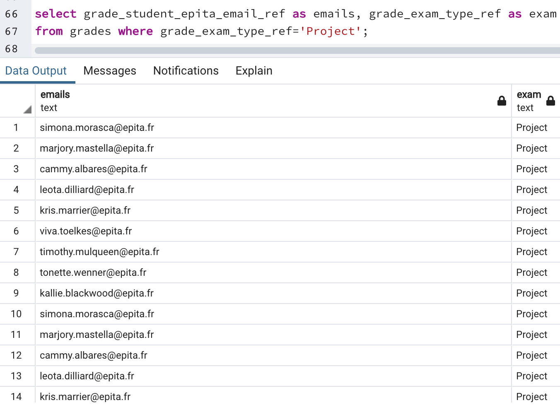

7:

-- GRADES type that are project with the course names all the columns.

select * from grades where grade_exam_type_ref = 'Project';

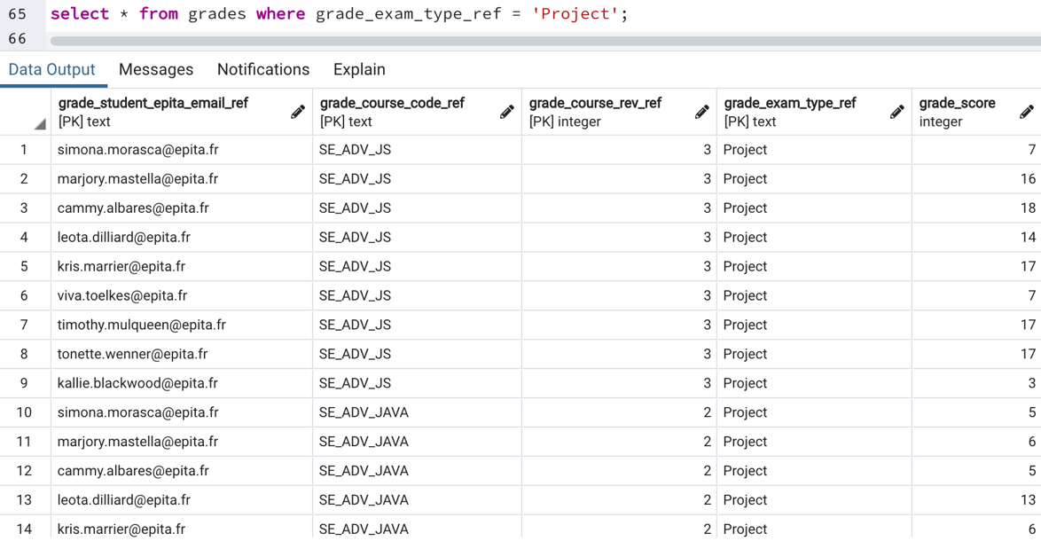

7.1 -- MAX or Highest GRADE in a subject

select MAX(g.grade_score) FROM grades as g where g.grade_course_code_ref = 'PG_PYTHON';

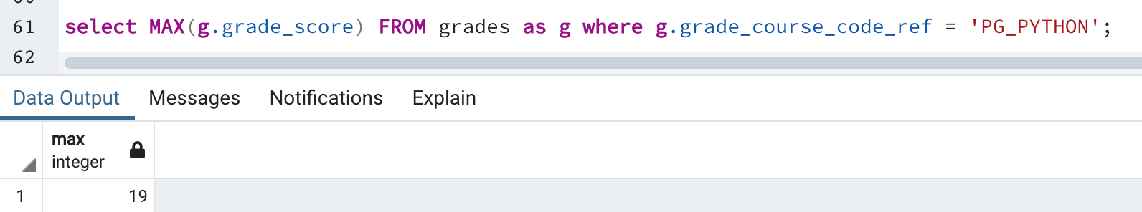

8:

-- Most or Highest Course Name and its Duration

select c.course_code, c.duration from courses as c ORDER by duration desc;

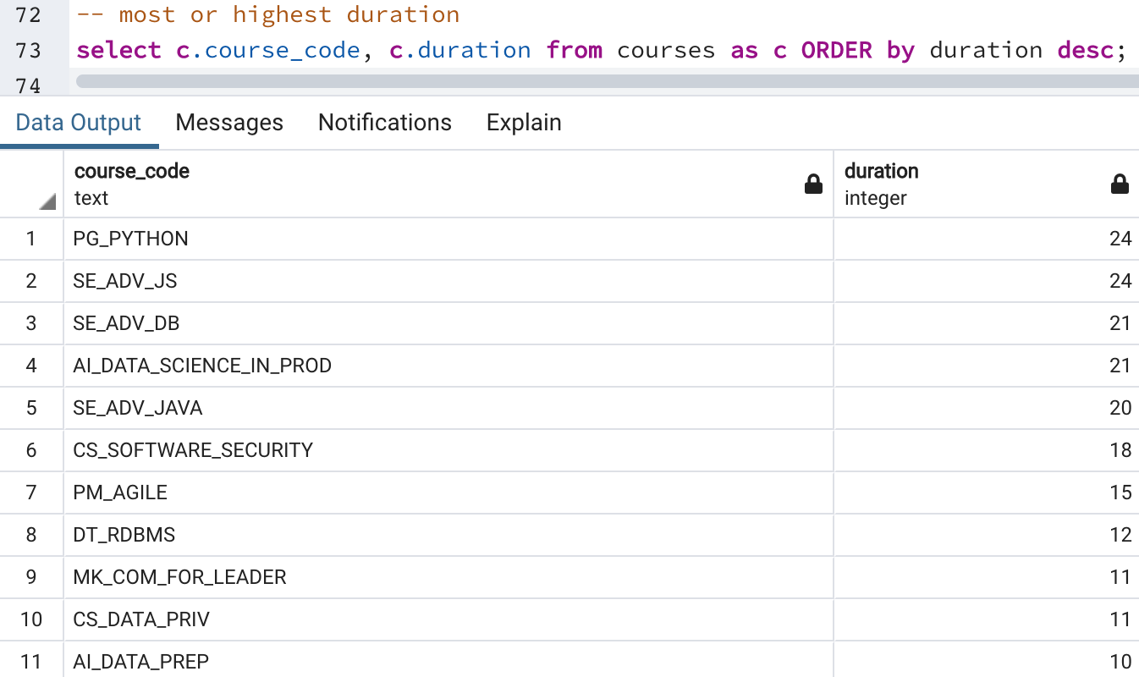

-- OR with all the columns and limit of 1.

select * from courses order by duration DESC limit 1;

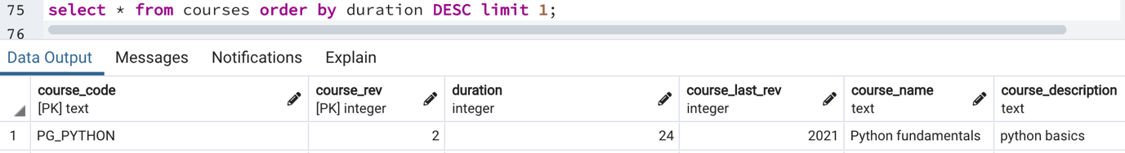

LIST OF QUERIES

-- list of customers

-- number of different products?

-- count of employees

-- total overall revenue

-- total revenue for one specific year

-- list of countries covered by delivery

-- list of available transporters

-- number of customer per countries

-- number of orders which are "ordered" but not shipped

-- all the orders from france and belgium

-- list of customers

select * from customers;

-- number of different products?

select * from products;

select distinct product_name from products;

-- count of employees

select * from employees;

select count(*) from employees;

-- list of countries covered by delivery

select * from customers;

select c.country from customers as c;

-- list of available transporters

select * from shippers;

select company_name from shippers;

-- number of customer per countries

select * from customers;

select country, count(*) from customers group by country;

-- all the orders from france and belgium

select * from orders;

select order_id, ship_country from orders where ship_country = 'France' or ship_country = 'Belgium';

ATTENDANCE TABLE

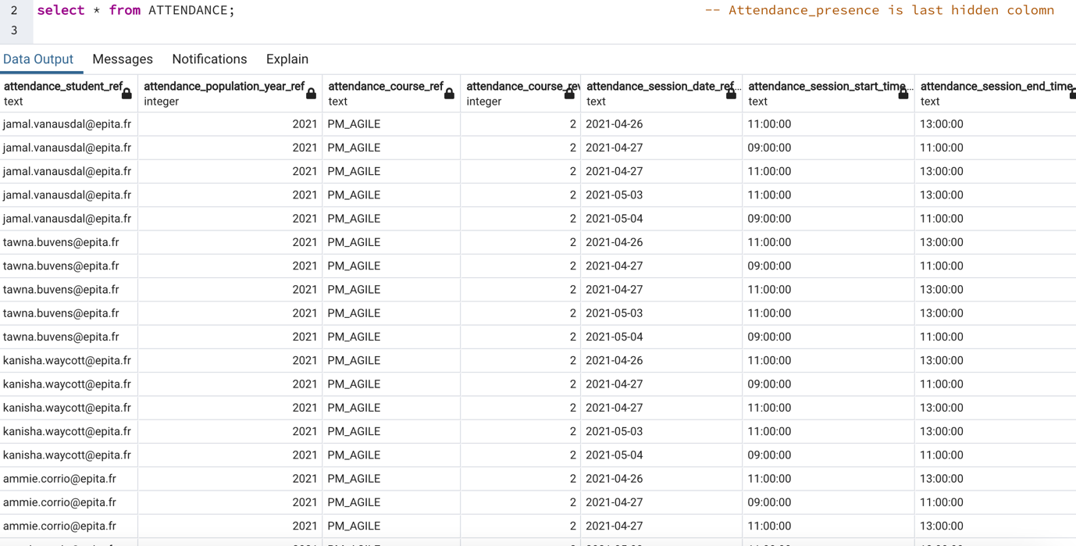

CONTACTS TABLE

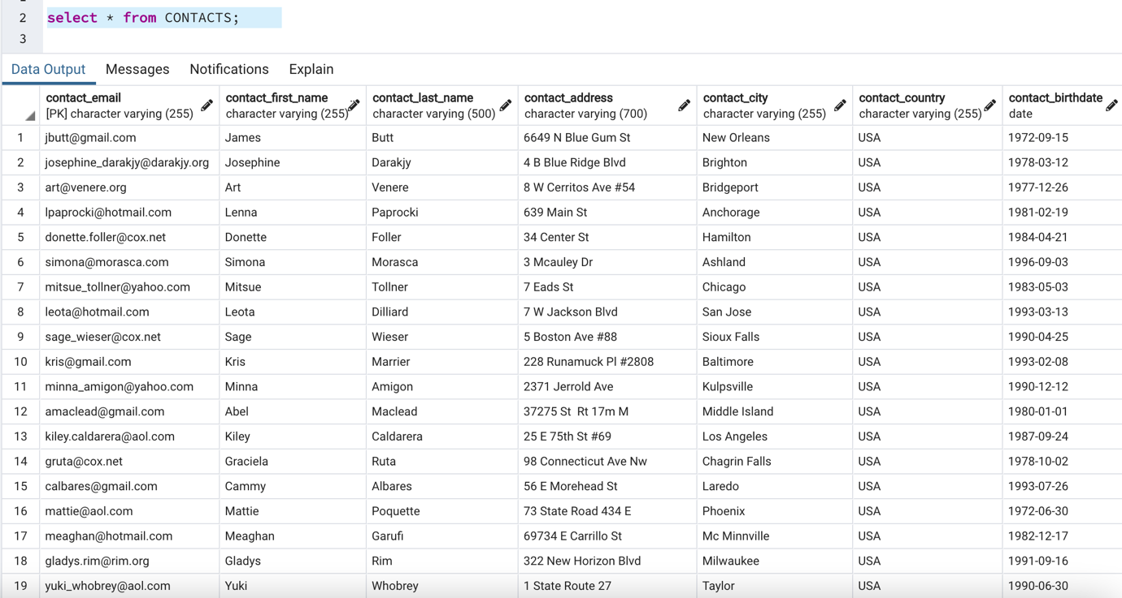

COURSES TABLE

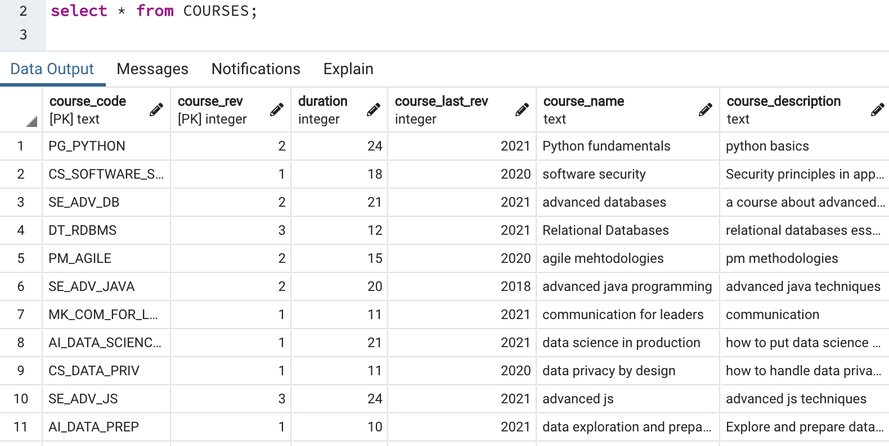

EXAMS TABLE

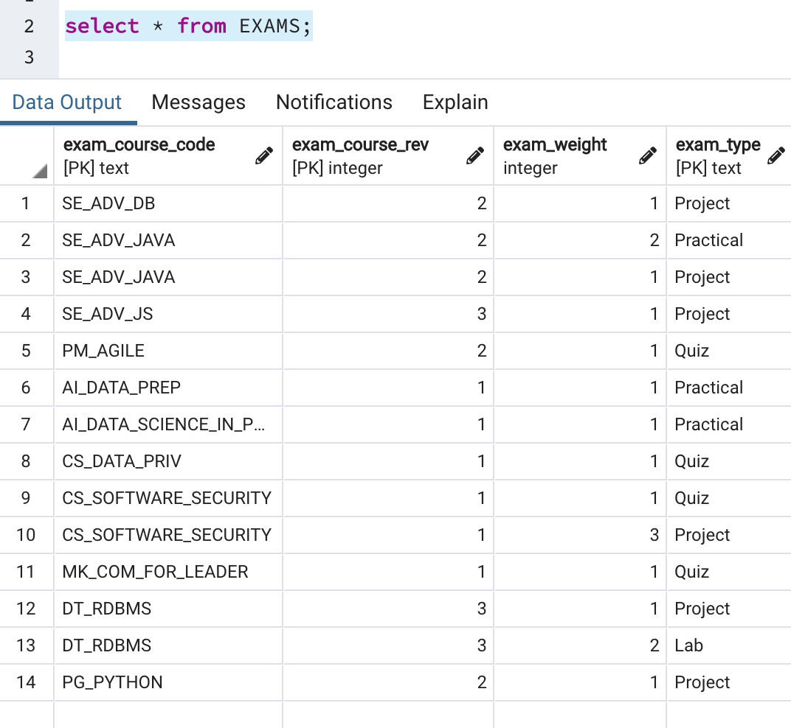

GRADES TABLE

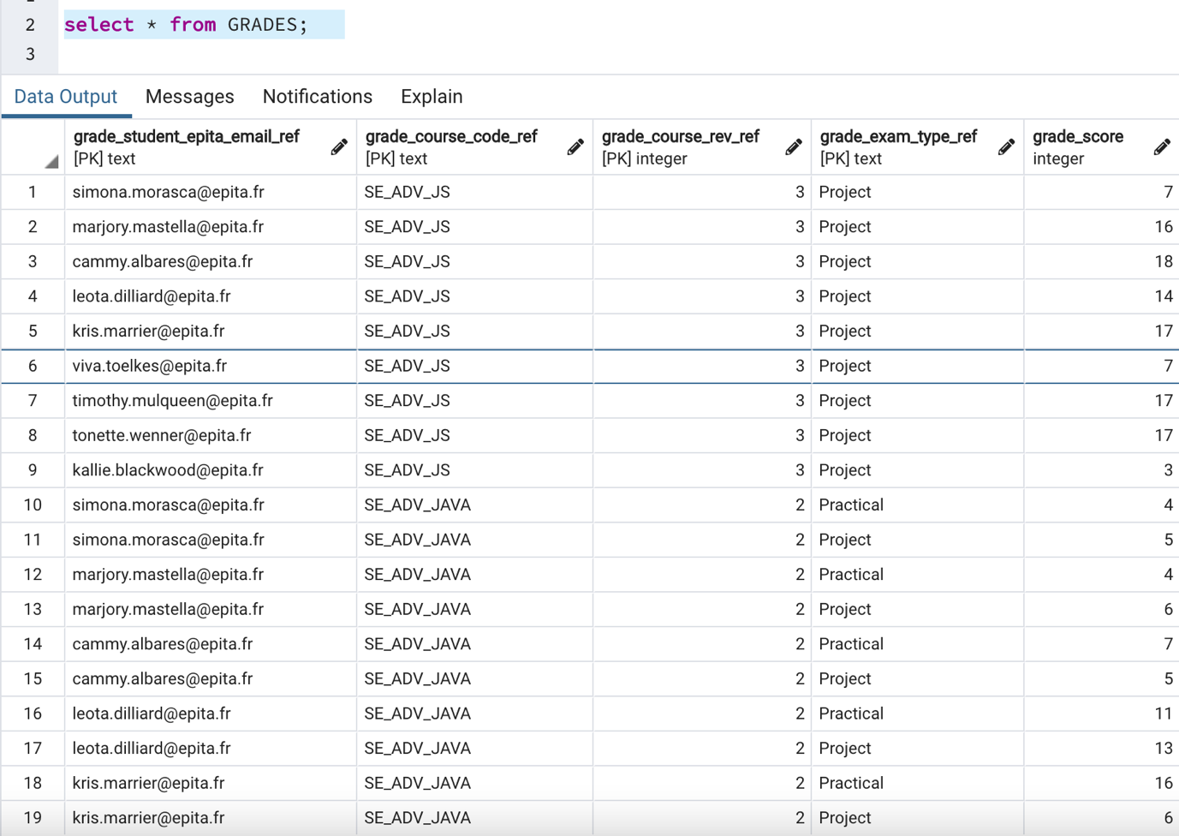

POPULATION TABLE

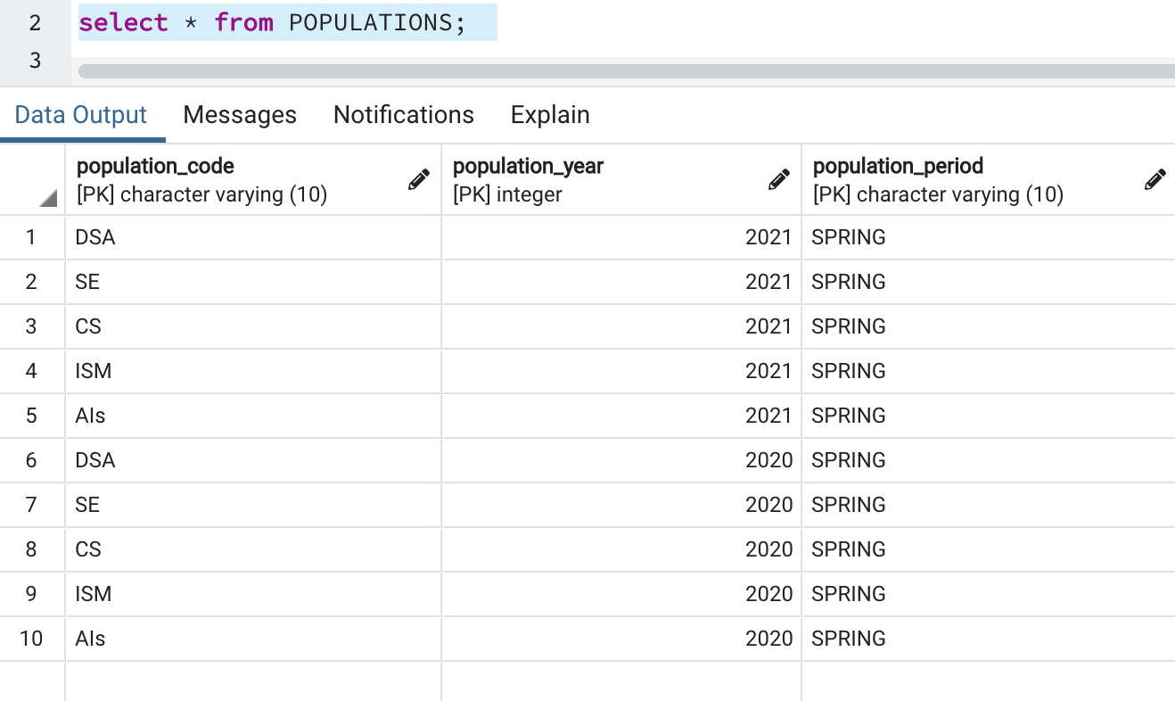

PROGRAMS TABLE

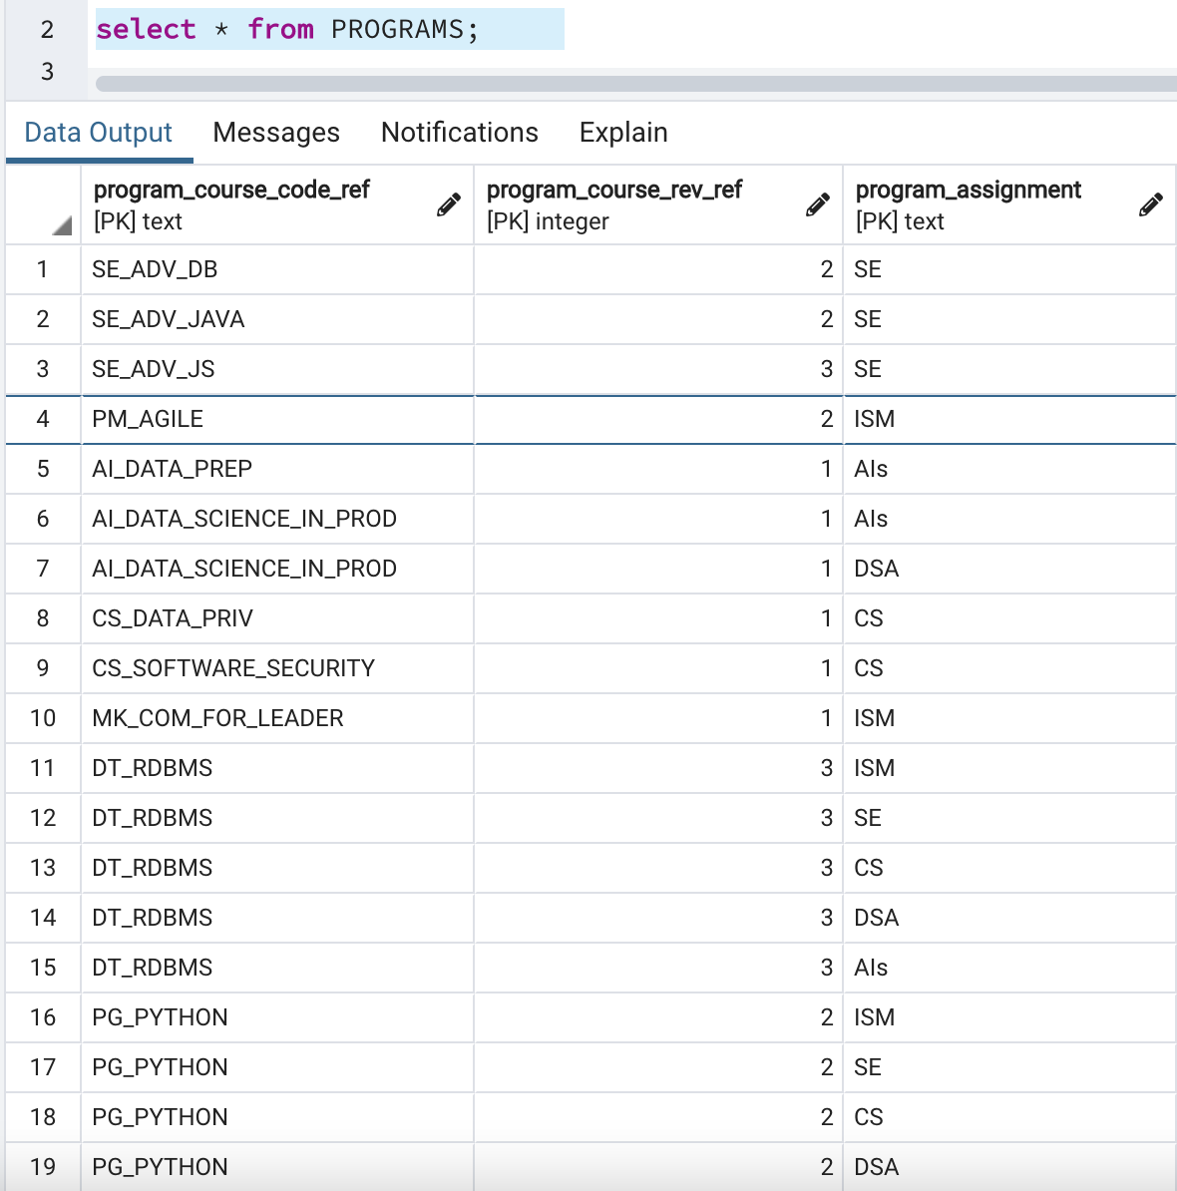

SESSIONS TABLE

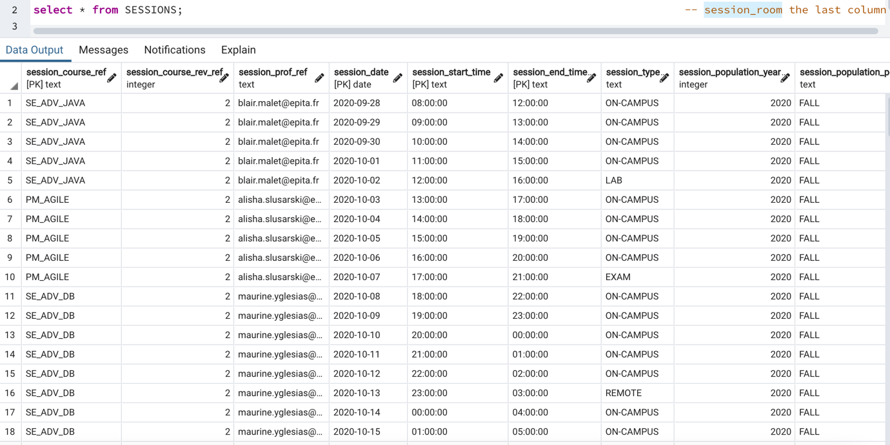

STUDENTS TABLE

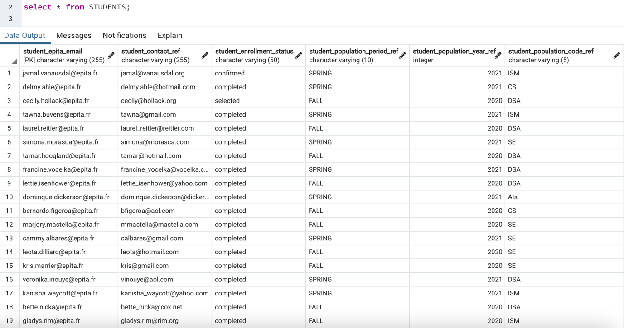

TEACHERS TABLE

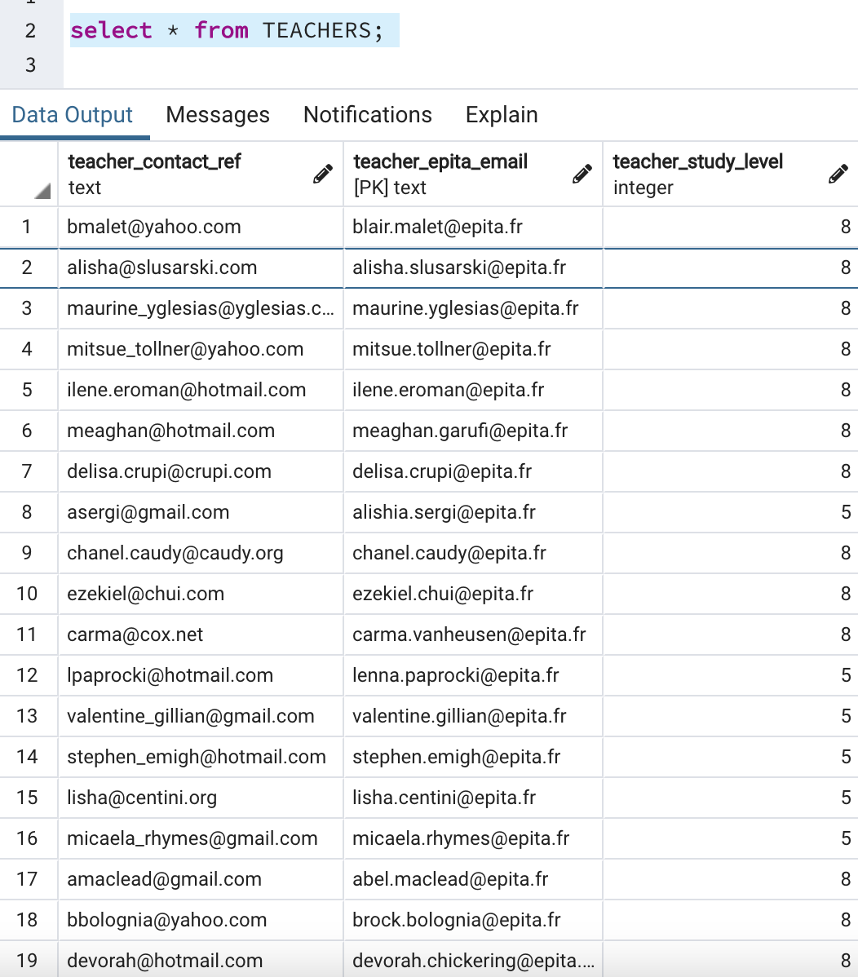

1. CREATING A TABLE

CREATE TABLE STUDENTS(

student_epita_email varchar(255) PRIMARY KEY,

student_contact_ref varchar(255) NOT NULL,

student_enrollment_status char(50) NOT NULL,

student_population_period_ref char(10) NOT NULL,

student_population_code_ref char(5) NOT NULL

);

1. Select * from students;
2. INSERT A ROW OF DATA INTO A TABLE

INSERT INTO STUDENTS

(student_epita_email, student_contact_ref, student_enrollment_status, student_population_period_ref, student_population_code_ref)

VALUES

('mohammad-mansoor.ahmadi@epita.fr', 'ahmadi.mansoor@outlook.com', 'confirmed', 'SPRING', 'SE');

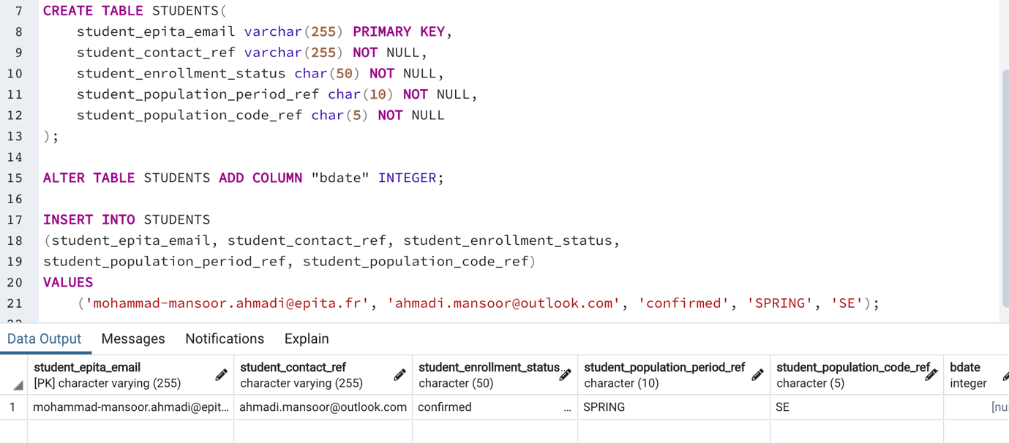

1. DROPING A COLUMN

ALTER TABLE STUDENTS DROP COLUMN "bdate";

1. DUPLICATING COLUMNS: columns must exist duplicating it. We 1st add two columns and then duplicate it.

ALTER TABLE DOCTORS ADD COLUMN "newCol" DATE;

ALTER TABLE DOCTORS ADD COLUMN "bdate" DATE;

UPDATE DOCTORS SET "newCol" = "bdate";

1. DROPING A TABLE

DROP TABLE STUDENTS;

1. CREATING A PRIMARY KEY

ALTER TABLE ONLY STUDENTS ADD CONSTRAINT student_epita_email PRIMARY KEY (student_epita_email);

1. CREATING A FOREIGN KEY

CREATE TABLE STUDENTS(

student_epita_email varchar(255) NOT NULL,

student_contact_ref varchar(255) NOT NULL,

student_enrollment_status char(50) NOT NULL,

student_population_period_ref char(10) NOT NULL,

student_population_code_ref char(5) NOT NULL

);

-- Creating a Primary Key

ALTER TABLE ONLY STUDENTS ADD CONSTRAINT student_epita_email PRIMARY KEY (student_epita_email);

-- Adding the Column of the Targeted Table

ALTER TABLE STUDENTS ADD COLUMN "doc_physicianidnumber" INTEGER;

-- Creating a Foreign Key for students table - created the primary column of doctors in students table.

ALTER TABLE STUDENTS ADD CONSTRAINT doc_pk FOREIGN KEY (doc_physicianidnumber)

REFERENCES DOCTORS (doc_physicianidnumber) ON DELETE SET NULL;

1. UPDATING VALUE IN ROWS: We changed it to unconfirmed from confirm

UPDATE students SET student_enrollment_status = 'unconfirmed' WHERE student_contact_ref='ahmadi.mansoor@outlook.com';

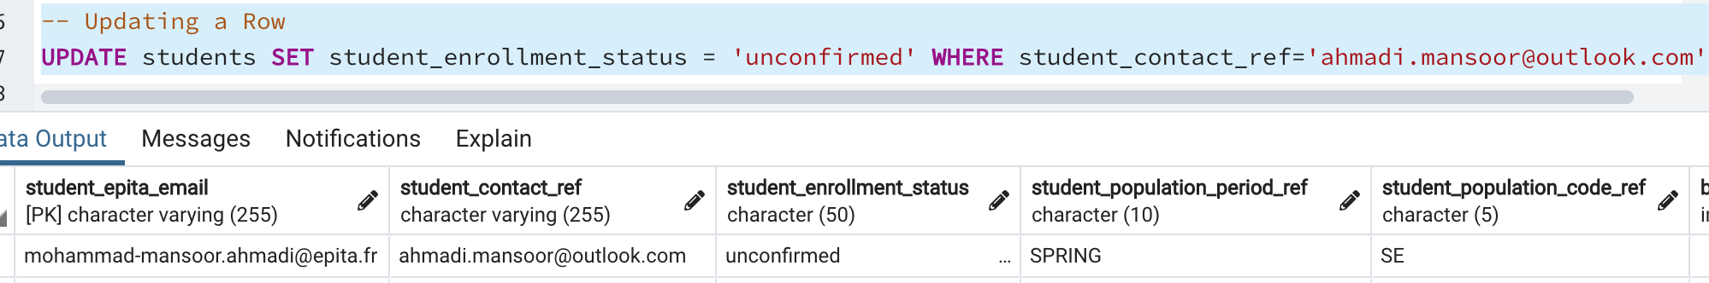

LIST OF PRACTICED COMMANDS

select * from students;

DROP TABLE STUDENTS;

ALTER TABLE STUDENTS DROP COLUMN "doc_id";

CREATE TABLE STUDENTS(

student_epita_email varchar(255) NOT NULL,

student_contact_ref varchar(255) NOT NULL,

student_enrollment_status char(50) NOT NULL,

student_population_period_ref char(10) NOT NULL,

student_population_code_ref char(5) NOT NULL

);

-- Creating a Primary Key

ALTER TABLE ONLY STUDENTS ADD CONSTRAINT student_epita_email PRIMARY KEY (student_epita_email);

-- Creating a Foreign Key

ALTER TABLE STUDENTS ADD CONSTRAINT doc_pk FOREIGN KEY (doc_physicianidnumber)

REFERENCES DOCTORS (doc_physicianidnumber) ON DELETE SET NULL;

-- Adding a column

ALTER TABLE STUDENTS ADD COLUMN "bdate" INTEGER;

-- Adding primary key column of another table in students

ALTER TABLE STUDENTS ADD COLUMN "doc_physicianidnumber" INTEGER;

-- Inserting Rows of Data

INSERT INTO STUDENTS

(student_epita_email, student_contact_ref, student_enrollment_status,

student_population_period_ref, student_population_code_ref)

VALUES

('mohammad-mansoor.ahmadi@epita.fr', 'ahmadi.mansoor@outlook.com', 'confirmed', 'SPRING', 'SE');

-- Duplicating columns

ALTER TABLE DOCTORS ADD COLUMN "newCol" DATE;

ALTER TABLE DOCTORS ADD COLUMN "bdate" DATE;

UPDATE DOCTORS SET "newCol" = "bdate";

-- Updating a Row

UPDATE students SET student_enrollment_status = 'unconfirmed' WHERE student_contact_ref='ahmadi.mansoor@outlook.com';

INSERT "CREATE A ROW"

How can we insert data into an existing table?

IT will create a new row in the FACILITIES table some specified rows and will insert values.

Insert into "name_of_table"all the columns that are supposed to exist already, and then the values

INSERT into facilities(facid, name, membercost, guestcost, initialoutlay, monthlymaintenance) values (9, 'Swimming Pool', 8, 16, 3000,3000)



Recommendation: Use the parenthesis for a clear view.



Command:

insert into cd.facilities(facid, name, membercost, guestcost, initialoutlay, monthlymaintenance) values (9, 'Mansoor', 1, 15, 10000, 100);

ROWS

* facid "primary-key"
* name
* membercost
* guestcost
* initialoutlay
* monthlymaintenance

VALUES FOR EACH OF THE ROW"

* facid = 9 "because, below 9 is given as primary keys."
* name = Mansoor
* membercost = 1
* guestcost = 15
* initialoutlay = 10000
* monthlymaintenance = 100

UPDATE "UPDATING A LINE or A ROW"

Once we inserted it. For modification we can update.

Update the table facilities column SET the membercost row to 10 WHERE the ROW name is Mansoor "the name mansoor will not be touched."

UPDATE facilities SET membercost=10 WHERE name='Swimming Pool';

UPDATE facilities SET membercost=10 WHERE name='Swimming Pool';





Command:

select * from cd.facilities;

UPDATE cd.facilities SET membercost=10 WHERE name='Mansoor';

NOTE:

During the update of a column, we must pay attention because "WHERE name='Mansoor' ", there can be so many rows by the name of Mansoor and it can be hurtful.

SET = This operator targets a column and replaces the old value.

Note:

Never do modifications using name because, we don't know if there is only one swimming pool in our database. There could be an interaction. Always use the ID or primary key.

Never code this way in an application.

In Applications it's always like this:

It's

* We search,
* We select a row,
* We display the detail,
* We either modify or delete.

NOTE: When you select, you have the idea of the row you selected. You can do WHERE for select only. NOT for UPDATE.

Before using the DELETE query, always make sure to take a backup by doing a select before the update.

DELETE A ROW

Delete the entire row. Don't do it. Always do a select where you will have a dump to reinterpret them and take a backup. It's a quick and definitive way of getting fired from a company.

DELETE from facilities WHERE name='Swimming Pool';

